GET STARTED WITH TABLEAU

[DATA VISUALIZATIONS WITH TABLEAU](https://www.coursera.org/learn/visualize-data/lecture/sLxV4/data-visualizations-with-tableau)

We've already discussed how helpful data visualizations can be when we want to fit a lot of knowledge into a small space.

Now it's time to explore a powerful tool that can help you create these visualizations and bring your data to life. It's called Tableau, a visual analytics platform that makes it a lot easier to explore and manage data.

You might remember hearing a bit about Tableau in some of our earlier discussions, but you're about to discover even more. Plus, when you get comfortable with Tableau, you'll find it even easier to use similar tools, giving you another skill that will help you stand out in the job hunt.

Coming up, we'll cover some of the features that make Tableau effective for visualizations and why it's used across industries. After that, the fun really starts.

We'll jump right in and explore the Tableau interface, identifying and applying the various tools it has to offer. I'll show you how to add data sources, control visual elements, and work with a variety of features that will make your visualization really powerful.

Like any software platform, there's some best practices to keep in mind. So I'll show you some examples of the good and the bad when it comes to visualizations.

We'll also get creative using color vision deficiency palettes to make our visualizations more accessible, and we'll show you how multiple data sources can be combined to tell a more comprehensive story. By the time we wrap up here, you'll be able to publish your own visualizations on Tableau.

I am so excited to lead you on this Tableau tour. It's another useful tool that you'll be able to turn to as a future data analyst so that you can visualize and publish data you care about. After all, data has a story, and this is your chance to share it with others. All right, let's discover what it's all about.

[TABLEAU PUBLIC AND OTHER ONLINE TOOLS](https://www.coursera.org/learn/visualize-data/lecture/HD29b/tableau-public-and-other-online-tools)

Welcome back. Mastering online tools like Tableau will make it easier for your audience to understand difficult concepts or identify new patterns in your data. Need to help a news outlet showcase changing real estate prices in regional markets? Check.

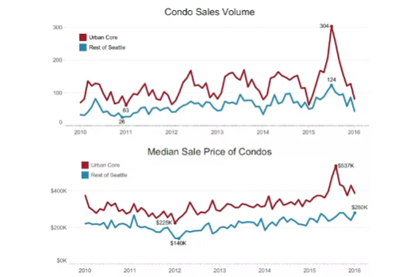

Want to help a nonprofit use their data in better ways to streamline operations? Check.

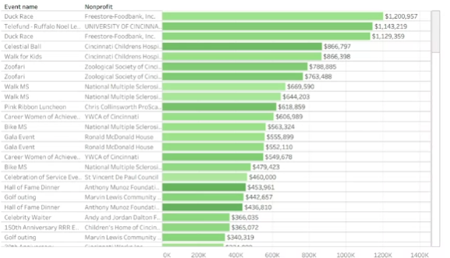

Need to explore what video games sales look like over the past few decades? Double check.

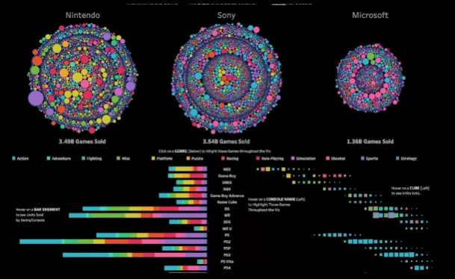

Many different kinds of companies are using Tableau right now to do all of these things and more.

This means there's a good chance you'll end up using it at some point. in your career. But I'm getting ahead of myself.

First, let's talk about what Tableau actually is.

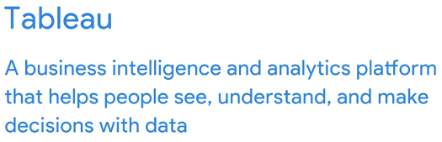

But it's not all business all the time. Take this data viz, for example, created by Tableau enthusiast Steve Thomas to record Bigfoot sightings across the US.

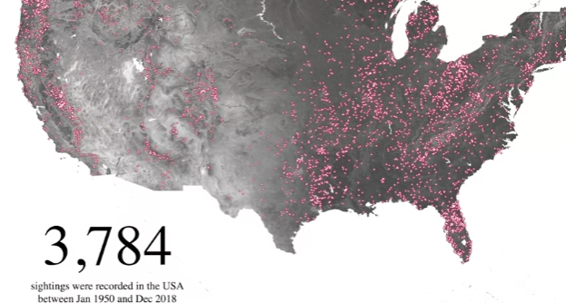

It's available on Tableau Public, which we will be using together in our activities in this course.

Tableau can help you make and easily share interactive dashboards, maps, and graphs with your data. Without any coding, you can connect to data and lots of formats like Excel, CSV, and Google Sheets. You might also find yourself working with a company that uses another option, like Looker or Google Data Studio. for example. Like Tableau, Looker and Google Data Studio help you take raw data and bring it to life visually, but each does this in different ways.

[BEGIN TO USE TABLEAU PUBLIC](https://www.coursera.org/learn/visualize-data/supplement/HyqLQ/begin-to-use-tableau-public)

As you’ve been learning, Tableau is a powerful data visualization tool used by data professionals around the world. Tableau offers a free browser version of its software, Tableau Public, which enables learners like you to try out its capabilities. Tableau Public is the software you will use throughout this course on data visualization. In this reading, you will sign up (if you haven’t already done so) and log in to Tableau Public. Then, you’ll be guided through the Tableau Public platform and account features.

## **Sign in to Tableau Public**

### **Sign in with an existing account**

If you already have a Tableau.com account, use your existing login credentials to sign in to Tableau Public. Click [here](https://community.tableau.com/s/tableau-public-faq#subhead6) to learn more. If this is your first time signing in to Tableau Public with your Tableau.com account, set an account password by resetting your password. To do so, select [reset password](https://id.tableau.com/resetPassword).

### **Sign in for the first time**

If you do not yet have a pre-existing Tableau.com or Tableau Public account, use these instructions to create one. If you have a Tableau Public account, skip ahead to the “Navigate Tableau Public” section

First, go to the [Tableau Public home page](https://public.tableau.com/). If this link does not open to the Tableau Public homepage, enter public.tableau.com in your browser’s address bar.

**Note:** Tableau Public works best on Chrome (Windows, Mac, Android), Edge (Windows), Firefox (Windows and Mac), Safari (Mac and IOS).

Next, click **Sign Up for Tableau Public**.

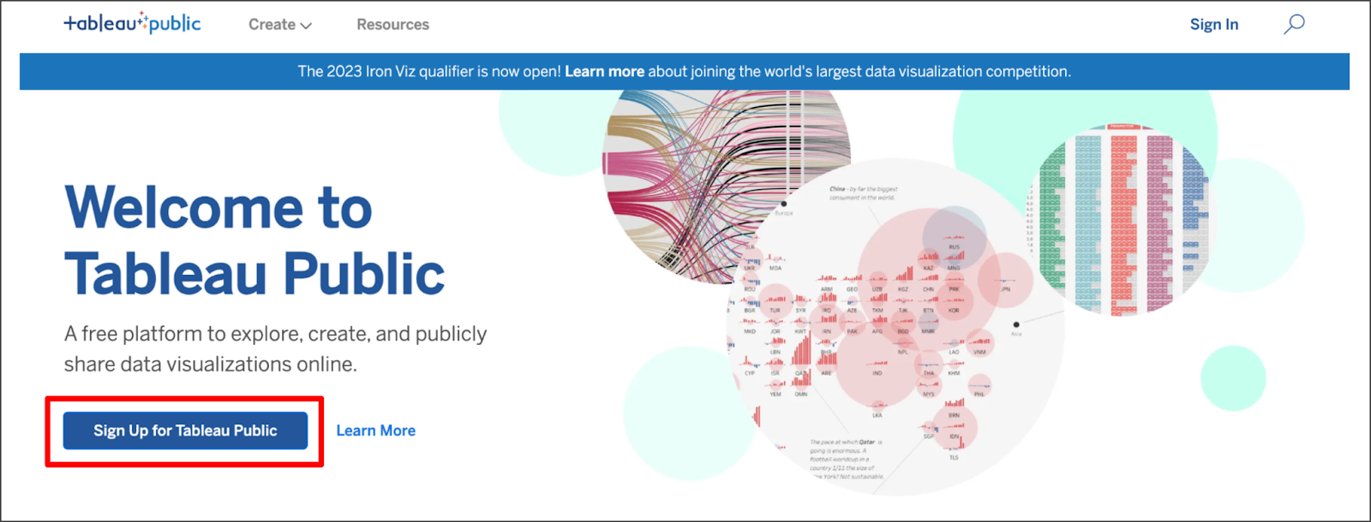

This is a free platform to explore, create, and publicly share data visualizations online. There is a hyperlink option to learn more.

Fill in all the required fields and click **Create My Account**.

## **Navigate Tableau Public**

The Tableau Public home page contains resources and guides to help data professionals learn more about and get inspired by data visualizations. You can explore any and all of the links on this landing page to help enhance your knowledge of Tableau. If you’re new to Tableau Public, the most helpful place to start is the Learn page, which has how-to videos, (free to use) sample data, and user forums.

### **Access My Profile**

During this course, the instructor will give you the opportunity to log in to Tableau Public and follow along in the creation of a data visualization. Select the user symbol icon on the Tableau Public homepage then **My Profile** from the dropdown menu to get started.

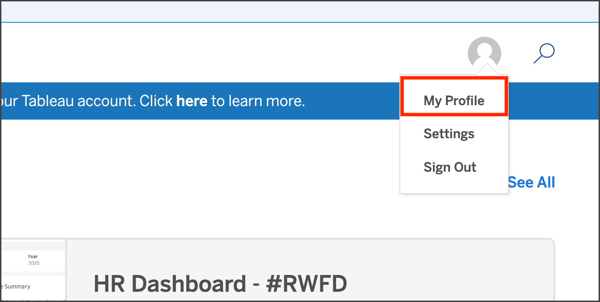

## **Create a Viz**

Within your Tableau Public profile, you’ll find tabs for **Vizzes**, **Favorites**, **Following**, and **Followers**. If you haven’t created a public viz yet, there are two buttons in the **Vizzes** tab: **Create a Viz** and **Explore Sample Data**. Selecting the Explore Sample Data button is a great way to try out the tool on your own and test how the software works in a sandbox-like environment. There is also a **Create a Viz** button at the upper right of the page. At the instructor’s prompt, select either of the two **Create a Viz** buttons.

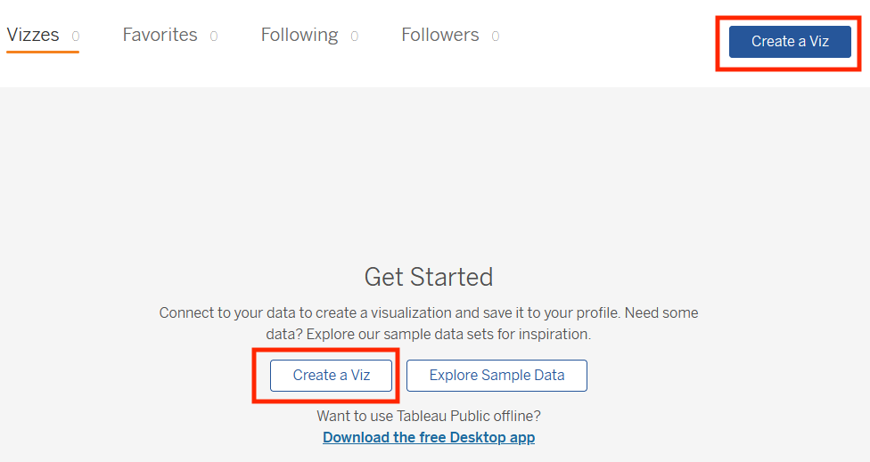

The text on this page reads: Connect to your data to create a visualization and save it to your profile. Need some data? Explore our sample data sets for inspiration. Want to use Tableau Public offline? There is a hyperlink to Download the free Desktop app.

After you select **Create a Viz**, you will be directed to a screen that asks you to connect to data. Tableau Public needs data to work with, such as a spreadsheet, .json, or .csv file, for example. When prompted by the instructor, upload the data provided using the **Connect to Data** screen. You can also use any of the sample data that you find in the [Learn](https://public.tableau.com/app/learn/sample-data) area.

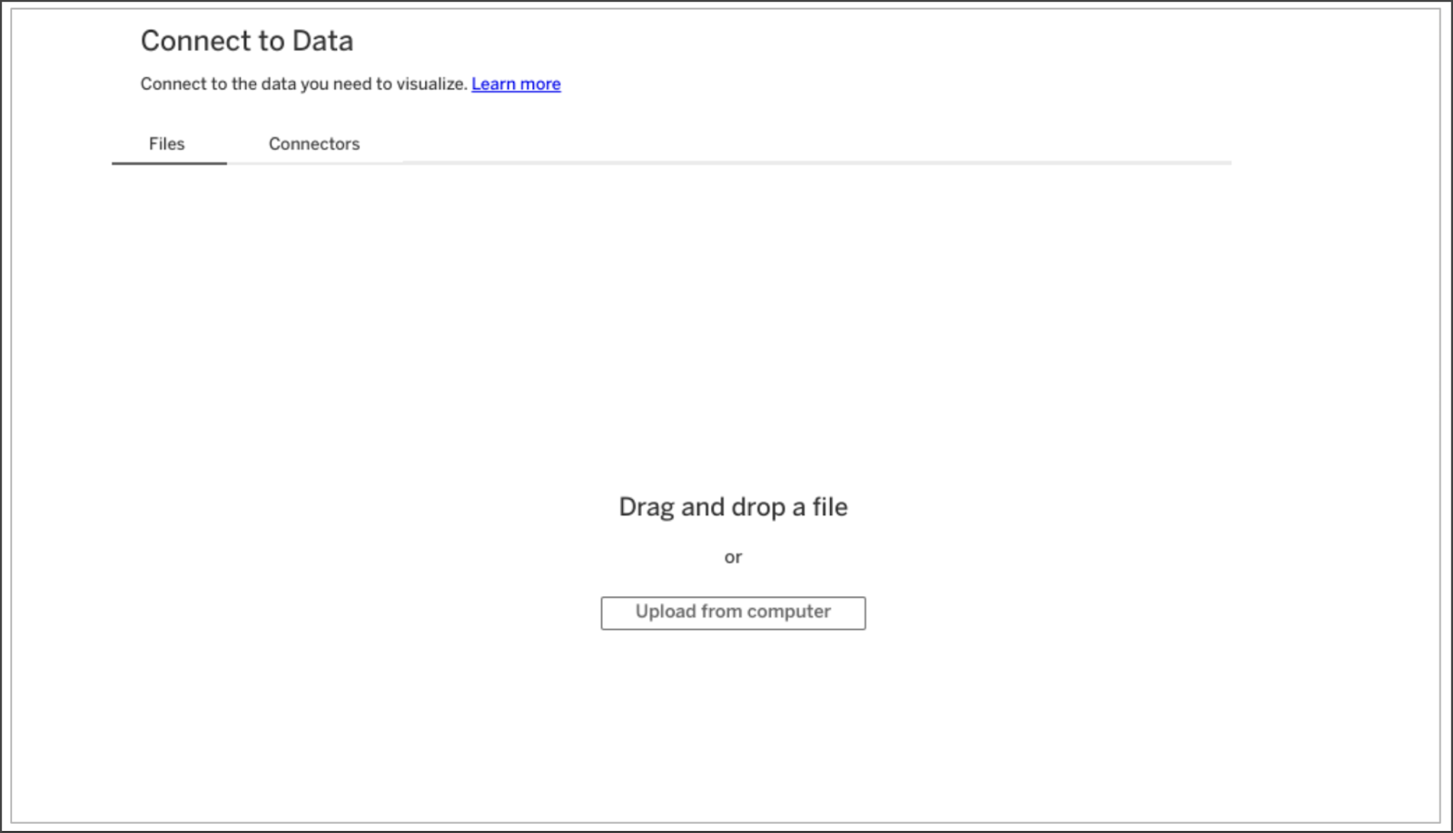

The Connect to Data screen. Connect to the data you need to visualize. There is a hyperlink to Learn more. The Files tab is open, where you can drag and drop a file or upload from the computer.

After you upload data, you are ready to start designing data visualizations. Happy designing, future Viz Whiz!

## **Key takeaways**

Now that you’ve completed this reading, you should be able to access Tableau Public with your own account, navigate the Tableau Public resources, and connect to data. These are your first steps to learning how to design data visualizations with Tableau!

## **Resources for more information**

To help you troubleshoot or to learn more, explore the following links:

* Tableau Public not working? Check out these [Technical specifications and storage requirements](https://www.tableau.com/products/techspecs#public).
* [The Tableau Public Discover page](https://public.tableau.com/app/discover) includes ‘Viz of the Day’ and other beautiful vizzes designed on the platform.
* [Google Career Certificates](https://public.tableau.com/profile/grow.with.google#!/) page on Tableau Public: This gallery contains all the visualizations created in the video lessons so you can explore these examples more in-depth.
* [Tableau Public resources page](https://public.tableau.com/app/learn/community-resources): This links to the resources page, including some how-to videos and sample data.
* [Tableau Accessibility FAQ](https://community.tableau.com/s/question/0D54T00000C6nsjSAB/faq-accessibility?_ga=2.189822891.1471813031.1653667812-1362170659.1601475625): Access resources about accessibility in Tableau visualizations using the FAQ, which includes links to blog posts, community forums, and tips for new users.
* [Tableau community forum](https://community.tableau.com/s/): Search for answers and connect with other users in the community on the forum page.
* [Build Your Data Literacy course](https://trailhead.salesforce.com/en/content/learn/trails/build-your-data-literacy): Build your data literacy skills in order to interpret, explore, and communicate effectively with data.

[MEET TABLEAU](https://www.coursera.org/learn/visualize-data/lecture/YbP1d/meet-tableau)

Hello, and welcome to the intersection of analytics and art, the place where data analysts like me go to unleash the true potential of data with meaningful visuals, and the place where future data analysts like you can also go to learn how to do this.

Welcome to Tableau, one of the many visualization platforms that helps you do more with your data. When you turn data into a visualization, you get to watch it transform before your eyes into a meaningful story that people can connect to and care about. Visualizations in Tableau are dynamic, not static. As a quick refresher, dynamic visualizations are interactive or change with time. The interactive nature of these graphics means your audience has some control over what they see, and you have incredible flexibility with how you create them. So let's create our own visualization using a preloaded table on Tableau Public. It's important to note that there's different ways to create visualizations in Tableau. Tableau has a few different offerings, but for this course we're using Tableau Public in browser, which is free.

One cool thing about Tableau Public is the public gallery with data viz examples from across the web. For now, you'll be working with one of these examples from the gallery. You'll be copying over data workbooks to your own profile to start creating and publishing visualizations.

To get started, sign into your Tableau Public account. You can check out an earlier reading for more details. Then, to access the Workbook, open the Google Career Certificates page on Tableau Public by clicking this link [Google Career Certificate Tableau](https://public.tableau.com/profile/grow.with.google#!/). This opens a new tab that is still linked to your account.

There are a few workbooks loaded up with different data sets that you can save to your own profile. These are a great starting point for creating your own visualizations. There will also be a resource following this video that goes through how to download Tableau and load your own data. But for now, let's use this gallery as a starting point. Now click to view the workbook titled, **Just the Data- World Happiness**.

This brings up the data table we use to help create the World Happiness data viz that's in the gallery. Next, go to the menu in the upper right corner and click Make a copy.

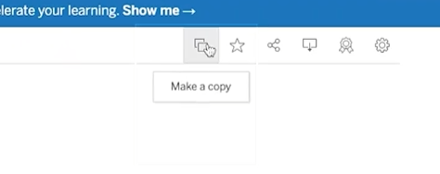

At this point, Tableau will save a copy of this workbook to your own profile, so you can create your own visualizations.

Now that you're working in your own copy, create a new worksheet so you can build a data viz from scratch. You'll click on Worksheet in the top menu, and then New Worksheet.

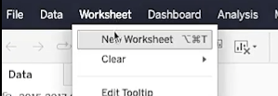

To start building your data viz, add Country as a detail in the marks shelf. You can do this by dragging the Country table over to the Detail icon.

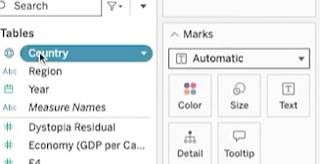

This sets up your viz as a world map to represent the data in the table.

Next, add the Happiness Score to the color on the mark shelf.

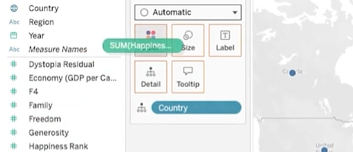

This applies a color scheme to the viz, in this case, shades of blue. This range of colors doesn't offer a lot of contrast, especially for people with color vision deficiencies.

So to adjust the colors, click the Color menu and click Edit Colors.

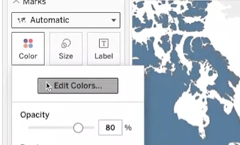

Then change the color scheme to Green-Blue Diverging and **check the box for stepped colors**, which shows a clearer difference between the highest and lowest happiness score.

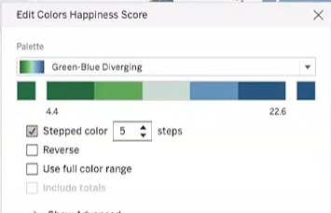

Darker blue means a higher happiness score, whereas darker green relates to a lower happiness score. You can see this broken down in the scale, so with just a couple of steps we have an interesting visualization that shows happiness data in a way that's easy to digest.

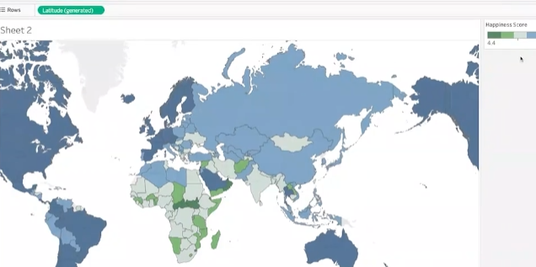

The countries and colors on the map are readable and offer some great insights. But let's keep going so we can explore more Tableau features to refine your data viz.

Because there are three years of data in the table we're using, you can **filter the data** to only include 2016. Using multiple years can also be useful depending on your objective. Regardless, you have lots of options for filtering. So we'll add Year to the filter shelf.

Then we'll choose to filter by year. And we'll select 2016. Let's focus our visualization on one region, the European region. To do this, move your cursor to find the view toolbar.

Use the tools in this toolbar to pan to and zoom in on the European region.

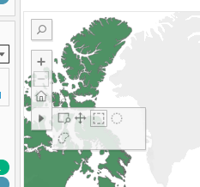

This takes some time and practice. Once you have a pretty good view of Europe and its surrounding areas, use the shape tools in the same toolbar to select as much of Europe as you can. Since we're practicing, make your best guess if you're not sure which countries to include. If you were working on a visualization that you were going to share with others, you'd want to double check that it was accurate.

Hover your cursor over one of the countries and it shows you data about that specific country, as well as all the countries you've selected in the region.

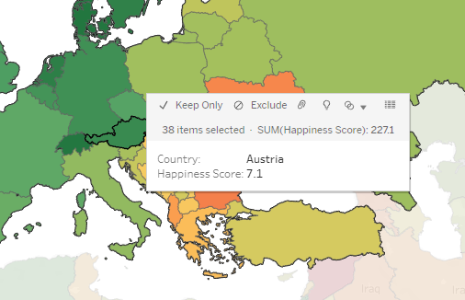

Then, use the Lasso selection tool to select just a few countries like this.

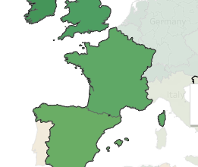

Keep Only, this applies another filter, this time to the country you're including in your viz.

You'll notice that the color scheme of these countries is updated. This reflects that the range of colors is now only being applied to these countries. Countries in this region might have been in the same part of the range when compared to the rest of the world, but now they're in different parts because the data being measured is specific to this region.

To make your viz even better, add the Happiness Score as a label in the map.

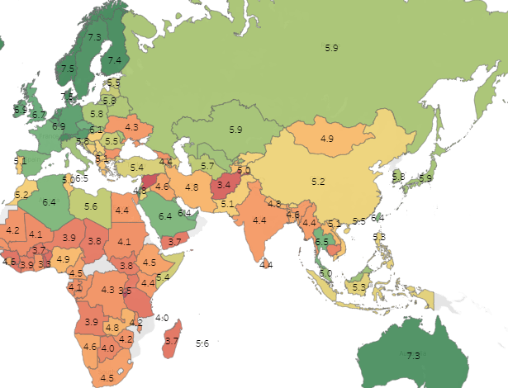

You can now see a happiness score for each country on the map. This adds an extra layer of detail to the viz, to help make a connection to the actual data. There's an option to change the data type of the happiness scores from decimals to whole numbers. But when you do this, you lose the contrast that the values with the decimals offer. So change it back to show the happiness score as a decimal.

Now, to make it even more interactive, let's add a filter with a slider. This will allow your audience to filter by happiness score, so they can focus on fewer countries. But first, let's bring in more of the map we started with. To do this, hover on the map, and select the zoom home icon in the toolbar to reveal more countries on the map.

Next we're going to add Happiness Score to the filter shelf. We'll select All Values and click Next.

Then for the range of values, we'll click OK, to accept the default settings. In the filter shelf, click the drop down to open the menu for the Happiness Score and select Show Filter.

If we select the drop down for the menu again, we can confirm that Show Filter has a checkmark next to it. You can toggle the checkmark to display or not display the filter.

When the show filter is marked, a slider is displayed to the right of the map. Now try filtering to show a happiness score of 6.0 or below.

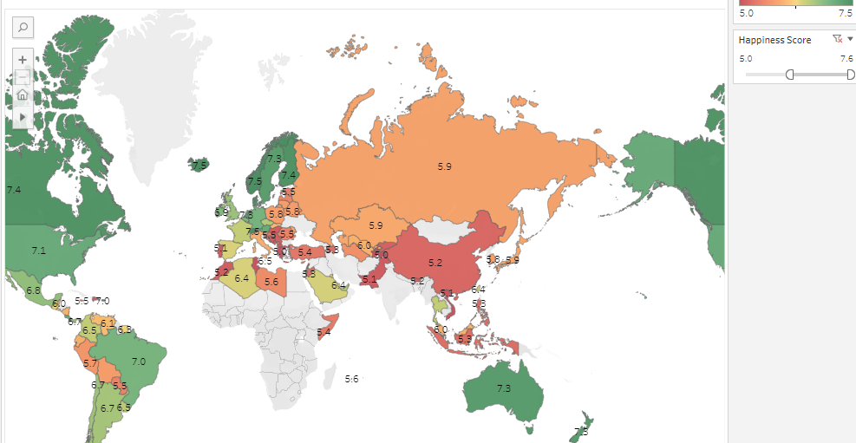

And there you have it, our first visualization based on data we brought in from an external source. Pretty powerful, right?

We'll save(publish) our viz so we can admire it anytime we want to, and maybe even practice using the Tableau tools with it. It's always important to save your work, but make sure not to include any personal information in your file name.

All of the data visualizations created in Tableau Public are visible to, well, the public.

You can also keep your visualizations hidden, you'll see the eye with a slash through it on your viz, and the viz will remain hidden. It's up to you, but lots of data viz created by users like you, are viewable. In fact, you can easily check them out by searching on Tableau Public.

Then you can search for any kind of data viz, including World Happiness visualizations. You'll come across all types of data viz, many with advanced settings.

Some of the examples you'll find in the gallery are stronger than others.

Coming up, we'll talk about effective data visualizations and some ways you can make your data viz work even stronger. See you soon.

[VISUALIZATIONS IN SPREADSHEETS AND TABLEAU](https://www.coursera.org/learn/visualize-data/supplement/bDdpK/visualizations-in-spreadsheets-and-tableau)

This reading summarizes the **seven primary chart types**:

**1- Column**

**2- Line**

**3- Pie**

**4- Horizontal bar**

**5- Area**

**6- Scatter**

**7- Combo**

Then, it describes how visualizations in spreadsheets compare to those in Tableau.

## **Primary chart types in spreadsheets**

In spreadsheets, **charts** are graphical representations of data from one or more sheets. Although there are many variations to choose from, we will focus on the most broadly applicable charts to give you a sense of what is possible in a spreadsheet. As you review these examples, **keep in mind that these are meant to give you an overview of visualizations rather than a detailed tutorial**.

Another reading in this program will describe the applicable steps and process to create a chart more specifically. When you are in an application, you can always select **Help** from the menu bar for more information.

* To create a chart In Google Sheets, select the data cells, click **Insert** from the main menu, and then select **Chart**. You can set up and customize the chart in the dialog box on the right.
* To create a chart in Microsoft Excel, select the data cells, click **Insert** from the main menu, and then select the chart type. Tip: You can optionally click **Recommended Charts** to view Excel’s recommendations for the data you selected and then select the chart you like from those shown.

These are the primary chart types available:

* **Column (vertical bar)**: a column chart allows you to display and compare multiple categories of data by their values.

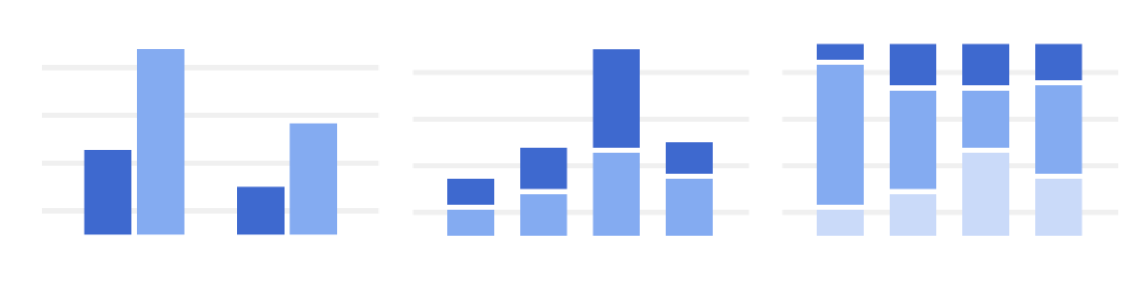

* **Line**: a line chart showcases trends in your data over a period of time. The last line chart example is a combo chart which can include a line chart. Refer to the description for the combo chart type.

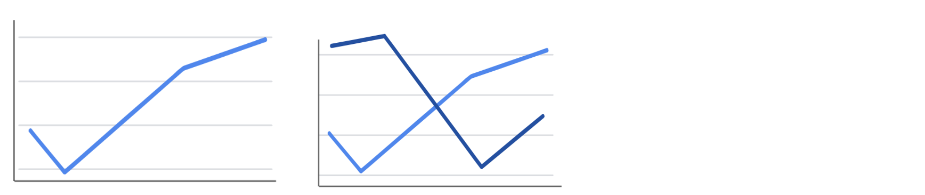

* **Pie**: a pie chart is an easy way to visualize what proportion of the whole each data point represents.

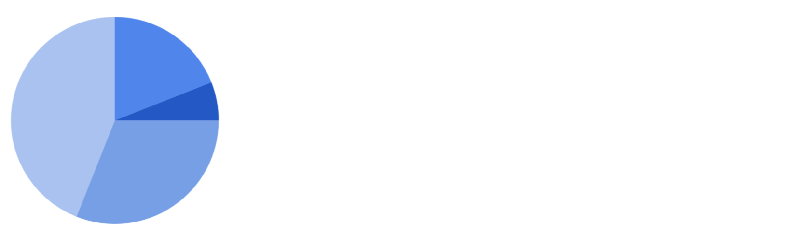

* **Horizontal bar**: a bar chart functions similarly to a column chart, but is flipped horizontally.

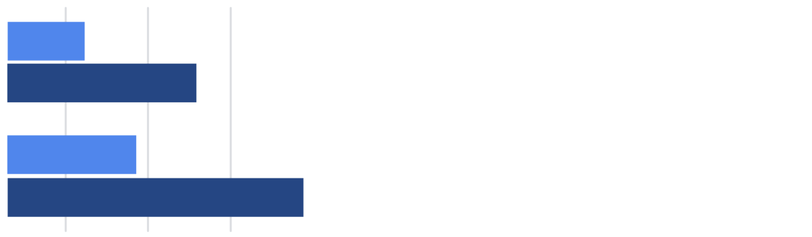

* **Area**: area charts allow you to track changes in value across multiple categories of data.

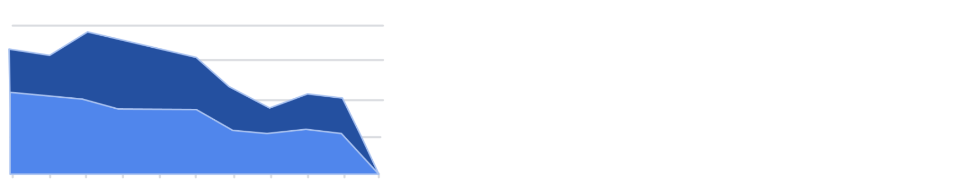

* **Scatter**: scatterplots are typically used to display trends in numeric data.

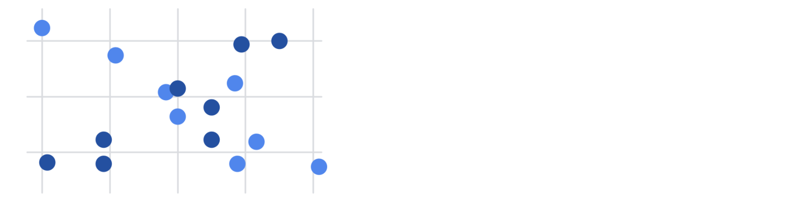

* **Combo**: combo charts use multiple visual markers like columns and lines to showcase different aspects of the data in one visualization. The example below is a combo chart that has a column and line chart together.

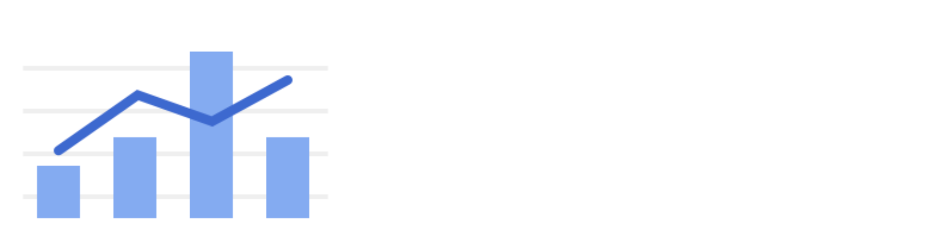

You can find more information about other charts here:

* [Types of charts and graphs in Google Sheets:](https://support.google.com/docs/answer/190718?hl=en) a Google Help Center page with a list of chart examples you can download.
* [Excel Charts](https://www.tutorialspoint.com/excel_charts/excel_charts_types.htm): a tutorial outlining all of the different chart types in Excel, including some subcategories.

## **How visualizations differ in Tableau**

As you have also learned, Tableau is an analytics platform that helps data analysts display and understand data. Most if not all of the charts that you can create in spreadsheets are available in Tableau. But, Tableau offers some distinct charts that aren’t available in spreadsheets. These are handy guides to help you select chart types in Tableau:

* [Which chart or graph is right for you?](http://www.tableau.com/sites/default/files/media/which_chart_v6_final_0.pdf) This presentation covers 13 of the most popular charts in Tableau.
* [The Ultimate Cheat Sheet on Tableau Charts](https://towardsdatascience.com/the-ultimate-cheat-sheet-on-tableau-charts-642bca94dde5). This blog describes 24 chart variations in Tableau and guidelines for use.

## **Types of visualizations in Tableau**

In addition to more traditional charts, Tableau also offers some more specific visualizations that you can use in your dashboard design:

* **Highlight tables** appear like tables with conditional formatting. Review the [steps to build a highlight table](https://help.tableau.com/current/pro/desktop/en-us/buildexamples_highlight.htm).
* **Heat maps** show intensity or concentrations in the data. Review the [steps to build a heat map](https://help.tableau.com/current/pro/desktop/en-us/buildexamples_highlight.htm).
* **Density maps** illustrate concentrations (such as a population density map). Refer to [instructions to create a heat map for density](https://help.tableau.com/current/pro/desktop/en-us/maps_howto_heatmap.htm).
* **Gantt charts** demonstrate the duration of events or activities on a timeline. Review the [steps to build a Gantt chart](https://help.tableau.com/current/pro/desktop/en-us/buildexamples_gantt.htm).
* **Symbol maps** display a mark over a given longitude and latitude. Learn more from this [example of a symbol map](https://interworks.com/blog/ccapitula/2014/08/18/tableau-essentials-chart-types-symbol-map/).
* **Filled maps** are maps with areas colored based on a measurement or dimension. Explore an [example of a filled map](https://interworks.com/blog/ccapitula/2014/09/23/tableau-essentials-chart-types-filled-map/).
* **Circle views** show comparative strength in data. Learn more from this [example of a circle view](https://interworks.com/blog/ccapitula/2014/10/17/tableau-essentials-chart-types-circle-view/).
* **Box plots**, also known as **box and whisker charts,** illustrate the distribution of values along a chart axis. Refer to the [steps to build a box plot](https://help.tableau.com/current/pro/desktop/en-us/buildexamples_boxplot.htm).
* **Bullet graphs** compare a primary measure with another and can be used instead of dial gauge charts. Review the [steps to build a bullet graph](https://help.tableau.com/current/pro/desktop/en-us/qs_bullet_graphs.htm).
* **Packed bubble charts** display data in clustered circles. Review the [steps to build a packed bubble chart](https://help.tableau.com/current/pro/desktop/en-us/buildexamples_bubbles.htm).

## **Key takeaway**

This reading described the chart types you can create in spreadsheets and introduced visualizations that are more unique to Tableau.

[CREATE A DATA VISUALIZATION IN TABLEAU](https://www.coursera.org/learn/visualize-data/lecture/64k7B/create-a-data-visualization-in-tableau)

Hi and welcome back. In this video, we're going to use tableau to create a database, a great way to share insights with others.

To begin, you'll need to download the data set we'll use for this activity. Click the link[CO2-Dataset.xlsx](https://docs.google.com/spreadsheets/d/1Um8szXOWKl4nbgBsSkCegC1qgxdH-YXi/template/preview)to create a copy of the data set and download it. If you don't have a Google account, download the data set directly from the attachment. As we go through the steps, you can put this video on one side of the screen and follow along in another window. You might notice your screen is slightly different from what you see here. Tableau might have updated its interface, but the steps should be pretty much the same. First, log in to Tableau Public. If you haven't created an account, go back to the reading about logging into Tableau Public. Okay, now go to the circle and select My Profile. From there, choose Create a Viz. This will open the Tableau Public interface.

From the Connect to Data window, go to the Files tab and upload the CO2 data set we downloaded earlier. Or you can navigate to the Data tab to the Tableau Public interface. Under the drop down, click new Data source, then open the CO2 data set. After the data uploads, the screen will show the data source interface. Underneath connections, double-click on the sheet CO2 data cleaned to load that data into the main part of the screen. You can also drag and drop the sheet into the area where it says Drag tables here. Click Update now to preview the data you opened in the bottom portion of the screen. Each row corresponds to a single data point, and each column represents a different feature. Tableau interprets the type of data in each column. Each icon represents a different type of data. For example, a number sign represents numerical data, while an abc represents string data. A globe represents geographic data, and so on. Tableau has interpreted the first two columns as geographic data, the third column as string data, and the last three columns as numeric data. All right, let's make a data viz that demonstrates the amount of CO2 emissions that come from each country. To do this, choose the Sheet 1 tab, on the far left of the screen is a banner with column names above a gray line. In tableau, these are called the dimensions of the data. Below this line, are the different measures that you can track for these dimensions.

To create a chart that displays the CO2 emissions per country, we're going to start by double-clicking the country name dimension. The main display will show a map of the countries on the planet, with dots indicating which countries are represented in the data.

The dots are all the same size because with no measure selected, tableau defaults to scale each country equally.

If you want to scale by CO2 emissions, we'll need to include a specific measure. Double-click or drag and drop onto the sheet the measure CO2 kilotons. This will change the size of the dots to be proportional to the amount of CO2 emitted.

Tableau has a wide selection of options for depicting the measures for a given dimension. Most of these options are contained in the middle column between the main display and the columns with dimensions and measures. Now, let's customize the look of our chart to better communicate trends in the data. If we drag and drop a measure on one of the marks, such as color, size, and label, we can change that aspect of the measure's visualization on the chart. For instance, say we want to change the color of the CO2 measure, we would drag the measure CO2 kilotons to the box with the color label. Then we can select this box to pull up a list of color options. Feel free to pause this video and play around with the different options, get creative. If you ever want to reverse a change that you make to a tableau sheet, just use the back arrow. There it is, we just created our first chart using Tableau. But what if we wanted to change the dimensions or measures? Instead of visualizing the CO2 per country, maybe we want to chart the CO2 per capita per region. To do this, we could double-click on the dimension Region and then do the same for the measure CO2 Per Capita. This builds a new chart. We can edit the title by hovering the cursor over the title box and clicking on the arrow to bring up a drop down menu. Then we'll choose the Edit Title. Let's give it the name Global CO2 Emissions. Or if we wanted to delete a chart, we could select the Clear Sheet button in the toolbar. This will wipe out the chart and bring us back to an empty sheet. Don't worry if you do this by accident or change your mind. The back button introduced earlier will bring the chart back. To delete a sheet entirely, right-click on the sheets tab and select Delete. We won't be able to delete a sheet if it's the only sheet in our file. But be careful, unlike clearing a sheet, deleting a sheet altogether cannot be undone.

Make sure to save your progress by hovering over the file tab and selecting Publish As. Congratulations, now you're ready to start visualizing your data. This is far from the end of the story, though. Soon you will explore more advanced tools in tableau.

[HANDS-ON ACTIVITY: CREATE A DATA VISUALIZATION IN TABLEAU](https://www.coursera.org/learn/visualize-data/quiz/AlTiN/hands-on-activity-create-a-data-visualization-in-tableau)



## **Activity Overview**



Now that you know how to create a visualization in Tableau, you’ll use the dataset and instructions in this activity to create your own visualization. If you have questions along the way, refer to the previous video, [Create a data visualization in Tableau](https://www.coursera.org/learn/visualize-data/lecture/64k7B/create-a-data-visualization-in-tableau).

In this activity, you’ll practice the following skills:

* Connect data to Tableau.
* Create a chart.
* Customize your chart.
* Delete a chart or sheet.

By the time you complete this activity, you’ll be able to create and customize visualizations in Tableau. This will enable you to share your valuable data insights with others.



### Step-By-Step Instructions

Follow the instructions to complete each step of the activity. Then answer the question at the end of the activity before going to the next course item.

### Step 1: Access the dataset

Click the following link and select Use Template to create a copy of the dataset. Download this dataset to your computer by selecting File > Download > Microsoft Excel (.xslx). If you don’t have a Google account, download the dataset directly from the attachment below.

Link to dataset: [CO2](https://docs.google.com/spreadsheets/d/1LwGHDgJkXSm8b0ziSDyC8pQGqjYVGpX9mAEVPs2KQgY/copy)

OR

Download dataset:

[CO2 Dataset](https://d3c33hcgiwev3.cloudfront.net/zhTyc2uLRjKsu73XdR0nQg_9f719016a1ca48ec8a728e28ab6fecf1_CO2-Dataset.xlsx?Expires=1715299200&Signature=isQbt0~4oLxg9ZRDXVb1fmQR5CaCCP8T84pwlx-Oy0Docxg6nXpREUTS~keilZFSxDoRq9JiSVIYDLS04HCiTneZhE62RTr6ZFWMYGLzR7X1VRUJuTc0lVzA7wIcOK9wYUOqRVdUwdo4R8K3p3M1kZT13JLauqcBi81IBKIGdGI_&Key-Pair-Id=APKAJLTNE6QMUY6HBC5A)

[XLSX File](https://d3c33hcgiwev3.cloudfront.net/zhTyc2uLRjKsu73XdR0nQg_9f719016a1ca48ec8a728e28ab6fecf1_CO2-Dataset.xlsx?Expires=1715299200&Signature=isQbt0~4oLxg9ZRDXVb1fmQR5CaCCP8T84pwlx-Oy0Docxg6nXpREUTS~keilZFSxDoRq9JiSVIYDLS04HCiTneZhE62RTr6ZFWMYGLzR7X1VRUJuTc0lVzA7wIcOK9wYUOqRVdUwdo4R8K3p3M1kZT13JLauqcBi81IBKIGdGI_&Key-Pair-Id=APKAJLTNE6QMUY6HBC5A)

[](https://d3c33hcgiwev3.cloudfront.net/zhTyc2uLRjKsu73XdR0nQg_9f719016a1ca48ec8a728e28ab6fecf1_CO2-Dataset.xlsx?Expires=1715299200&Signature=isQbt0~4oLxg9ZRDXVb1fmQR5CaCCP8T84pwlx-Oy0Docxg6nXpREUTS~keilZFSxDoRq9JiSVIYDLS04HCiTneZhE62RTr6ZFWMYGLzR7X1VRUJuTc0lVzA7wIcOK9wYUOqRVdUwdo4R8K3p3M1kZT13JLauqcBi81IBKIGdGI_&Key-Pair-Id=APKAJLTNE6QMUY6HBC5A)

### Step 2: Connect data to Tableau

1. Log in to Tableau Public. If you have not yet created an account, refer to the reading [Begin to use Tableau Public](https://www.coursera.org/learn/visualize-data/supplement/HyqLQ/logging-into-tableau-public).

Note: Tableau frequently updates its user interface. The latest changes may not be reflected in the screenshots presented in this activity, but the principles remain the same. Adapting to changes in software updates is an essential skill for data analysts, and it’s helpful for you to practice troubleshooting. You can also reach out to your community of learners on the discussion forum for help.

2. Select the user profile icon and choose My Profile to display your Tableau profile and any vizzes you’ve created.

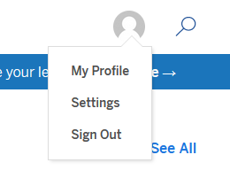

3. Select the Create a Viz button.

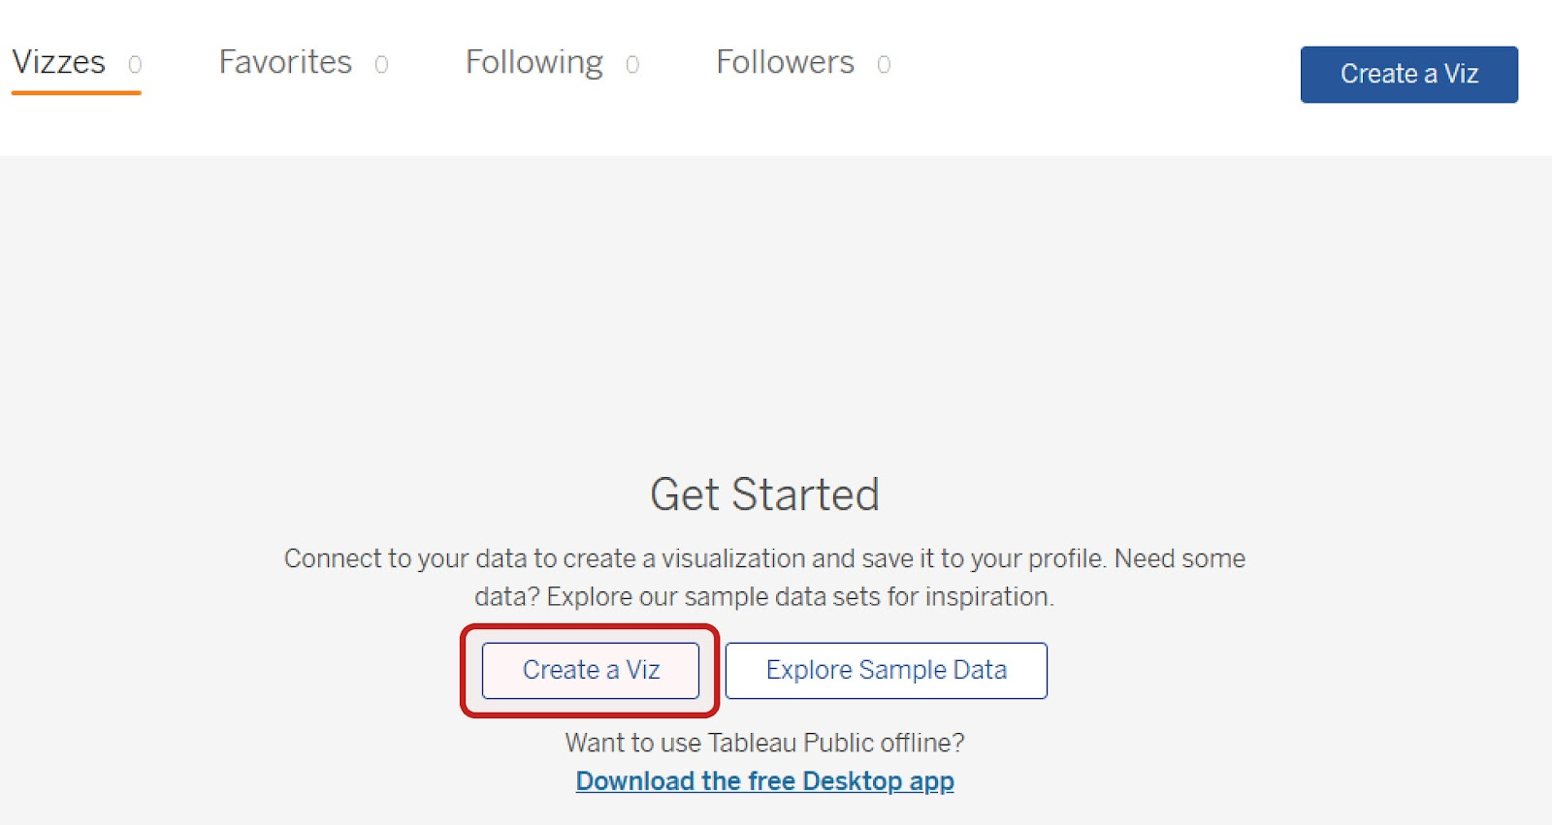

4. When you select Create a Viz, Tableau may open the Connect to Data dialog box. If so, select the Files tab and upload the CO2 dataset you downloaded earlier.

If selecting Create a Viz does not open the Connect to Data dialog box, in the Tableau Public interface, select the Data tab and then New Data Source. Upload the CO2 dataset.

5. After you upload the data, notice the list of data connections and sheets beside the main Data-Source Interface. The data connection is the CO2 dataset you’ve connected. It contains eight sheets, including one labeled CO2 Data Cleaned.

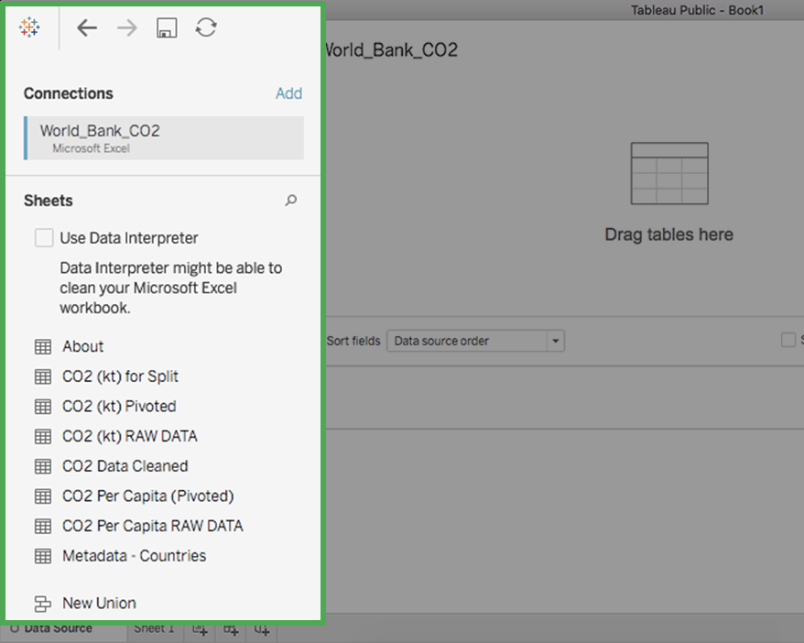

6. Double-click on the sheet CO2 Data Cleaned to load that sheet's data into the main part (canvas) of the Tableau Public page. Alternatively, drag and drop the sheet onto the canvas where it says Drag tables here.

Note: Loading a sheet twice may cause you to inadvertently create a table relationship between the loaded sheets (similar to joining tables in SQL). You’ll explore this later in the course. For now, if you do this accidentally, don’t worry! Just right-click on the second box to remove it from the table listings.

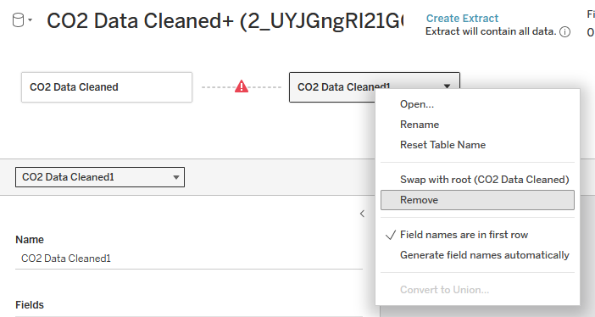

A dotted line with a warning symbol connects the two. The down arrow in the right of CO2 data cleaned 1 field has been selected, which opens a menu with the following choices: Open, Rename, Reset Table Name, Swap with root (CO2 Data Cleaned), Remove, Field names are in first row, Generate field names automatically. The Remove option is highlighted.

7. When the sheet is loaded, Tableau displays the table schema with the field names, data types, etc. Select the Update Now button to bring up the first 100 rows in the table; you can increase the number of rows in the settings above the data view. In the following image, the number of rows displayed has been increased to 1,000.

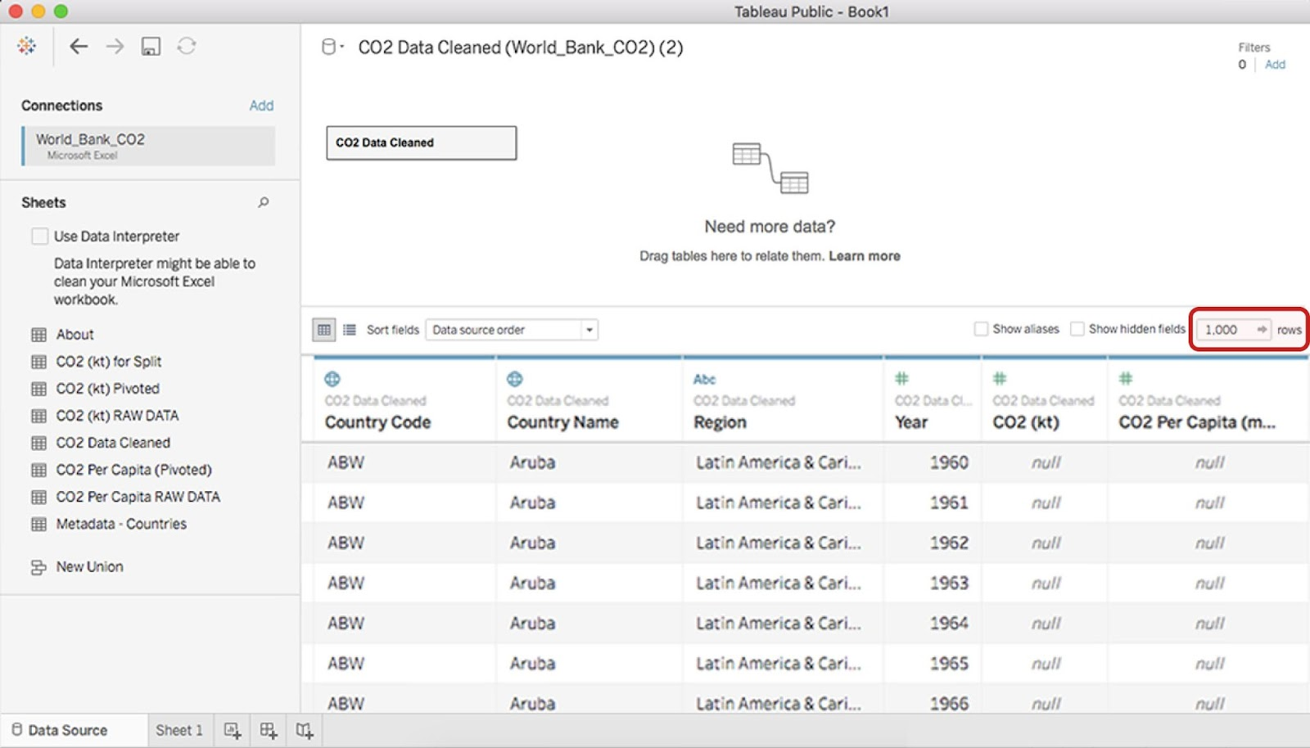

Each row corresponds to a single data point, and each column represents a different feature.

Tableau automatically interprets the type of data in each column and displays the following icons above the column names, to indicate how Tableau has interpreted the data in the column:

* #: Numeric data
* Abc: String data
* Globe: Geographic data
* Calendar: Date data
* Calendar: Date and time data

In the previous image, Tableau has interpreted the first two columns as geographic data, the third column as string data, and the last three columns as numeric data.

### Step 3: Access your data in Tableau

Now that you have all of your data loaded into Tableau, you can use it to create a visualization in which the CO2 emissions are displayed per country.

Select the Sheet 1 tab to open the New workbook pane in the display.

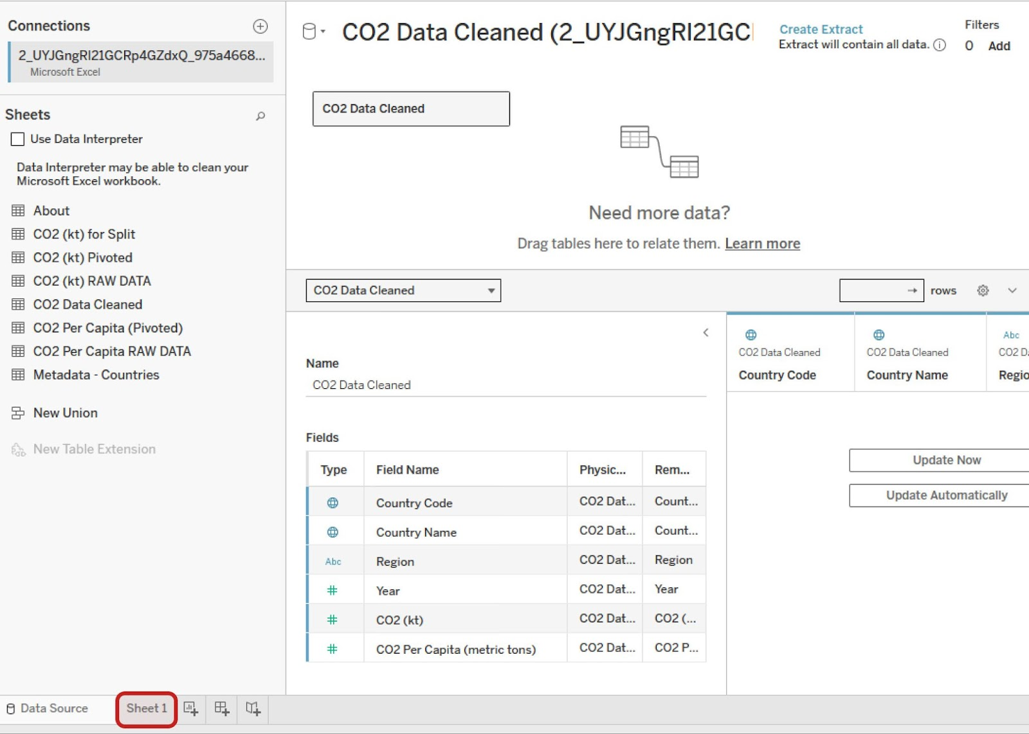

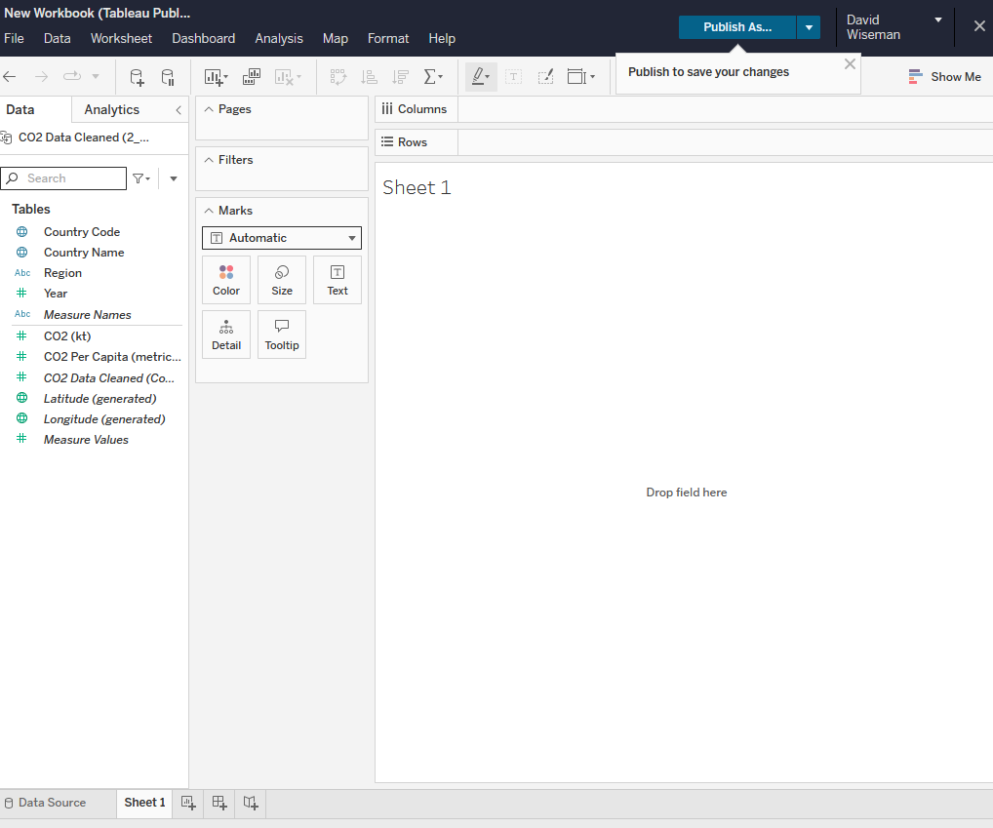

### Step 4: Understand dimensions and measures

The Data pane in the side bar displays column names in a list. In Tableau and most business intelligence software, you will find two types of data elements: dimensions and measures. According to the [Tableau documentation](https://help.tableau.com/current/pro/desktop/en-us/datafields_typesandroles.htm):

* Dimensions contain qualitative values (such as names, dates, or geographical data). You can use dimensions to categorize, segment, and reveal the details in your data. Dimensions affect the level of detail in the view.
* Measures contain numeric, quantitative values that you can measure. Measures can be aggregated. When you drag a measure into the view, Tableau applies an aggregation to that measure (by default).

In the Data pane of the Tableau side bar, you’ll see dimensions listed above the gray line and measures below the gray line (under Measure Names). These allow you to build and customize charts.

### Step 5: Create a visualization chart of CO2 emissions

Now, create a chart that displays the CO2 emissions per country. In the Data pane of the sidebar, double-click the Country Name dimension. The canvas displays a map of the countries with points indicating which countries are represented in the data.

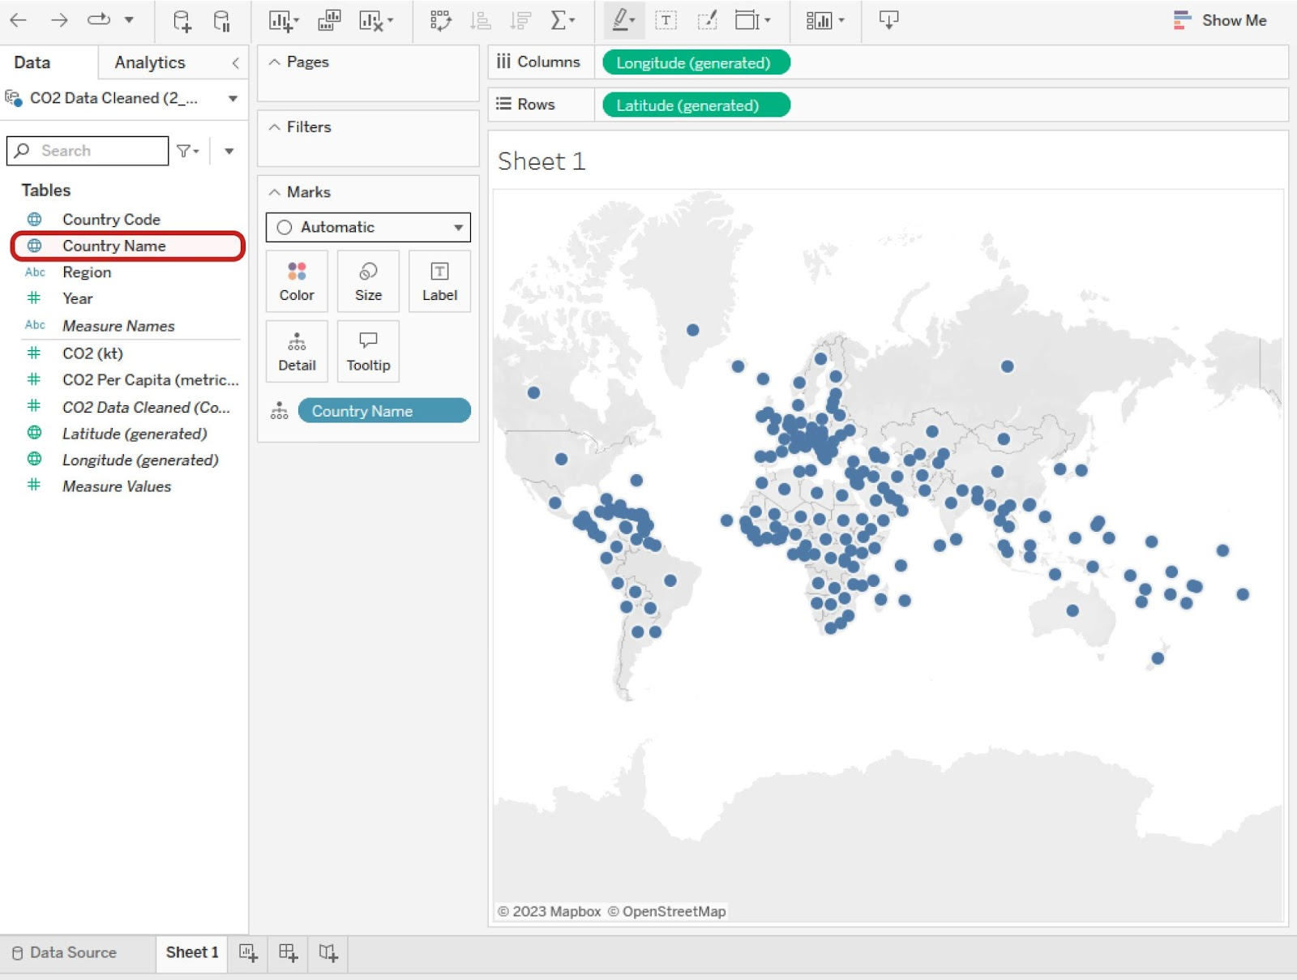

The points are all the same size because, if there is no measure selected, Tableau defaults to scale each country equally. If you want to scale point size by kilotons (kt) of CO2 emissions, you need to include a specific measure.

To do this, double-click (or drag and drop onto the sheet) the measure CO2 (kt) in the Data pane. This changes the size of the dots to be proportional to the amount of CO2 emitted, as in the example below.

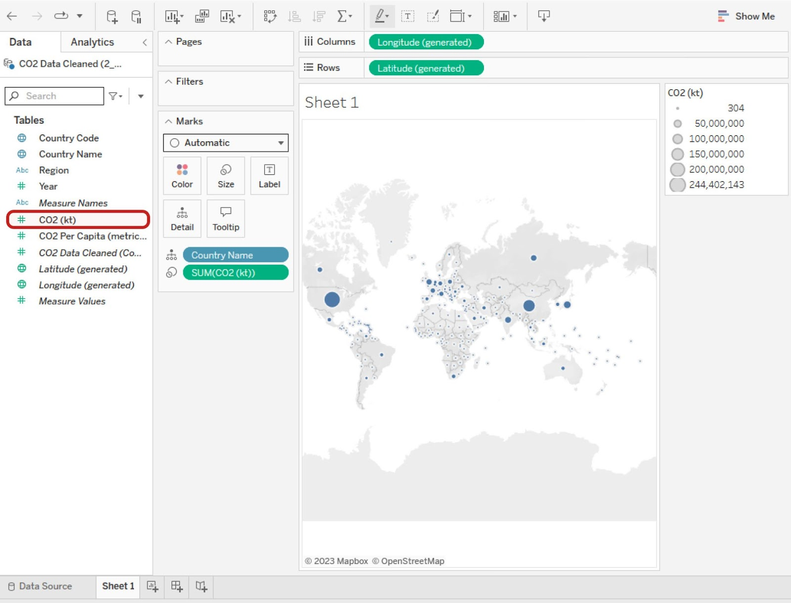

There is a callout box around CO2 (kt). The world map now displays a dot marker on each country, but the point vary in size based on each country’s CO2 emissions.

Tableau has a wide selection of options for depicting the measure of a given dimension. Most of these options are contained in the Marks card, Filter shelf, and Page shelf.

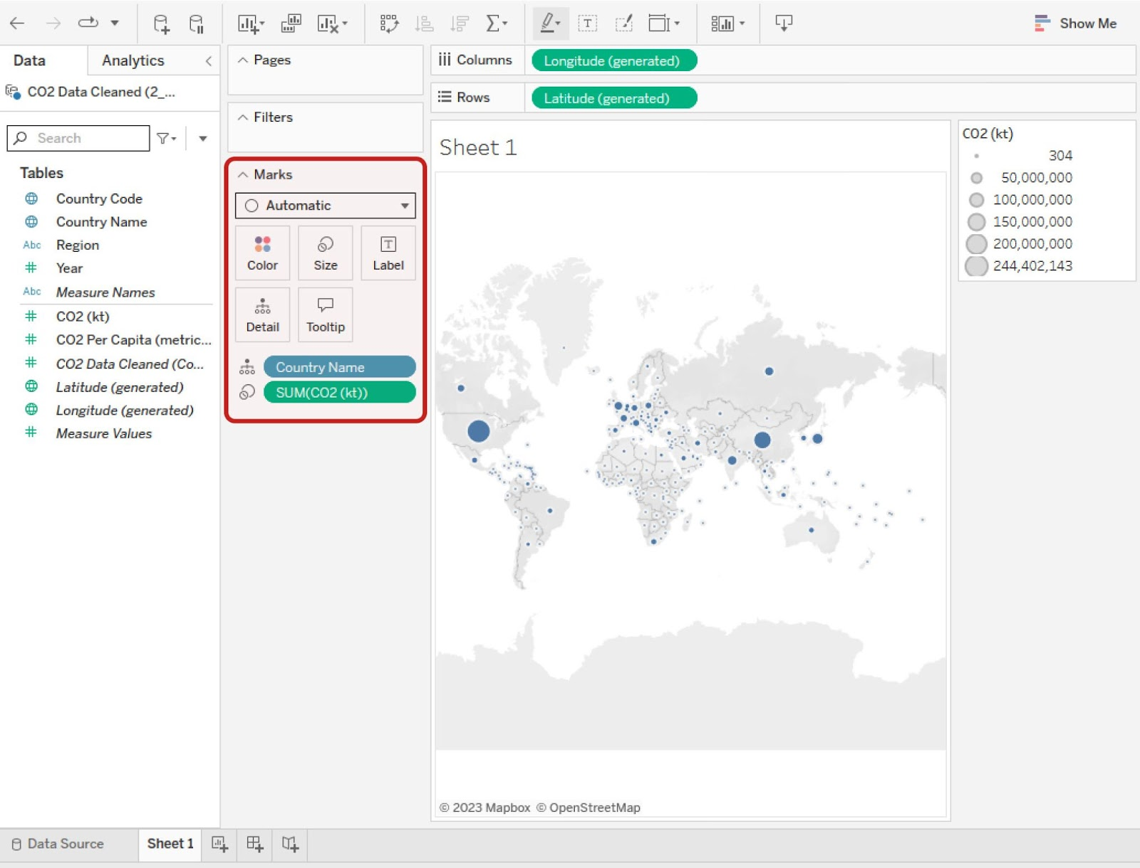

### Step 6: Customize your chart's dimensions and measures

If you drag and drop a measure on one of the option classes, such as Color, Size, or Label, you can change that aspect of the measure’s visualization on the chart.

For example, if you want to change the color of the CO2 measure, drag the measure CO2 (kt) from the sidebar to the Marks card and drop it on the Color box. This will change the measure’s configuration to a color breakdown. Then, select the Color box in the Marks card to pull up a menu for changing the color and its options. To change the color, select the Edit Colors button.

Try out the different options available. You can always reverse a change by selecting the Back arrow button in the toolbar or using your computer's default undo keyboard shortcut. Similarly, you can redo changes you make by selecting the Forward arrow button.

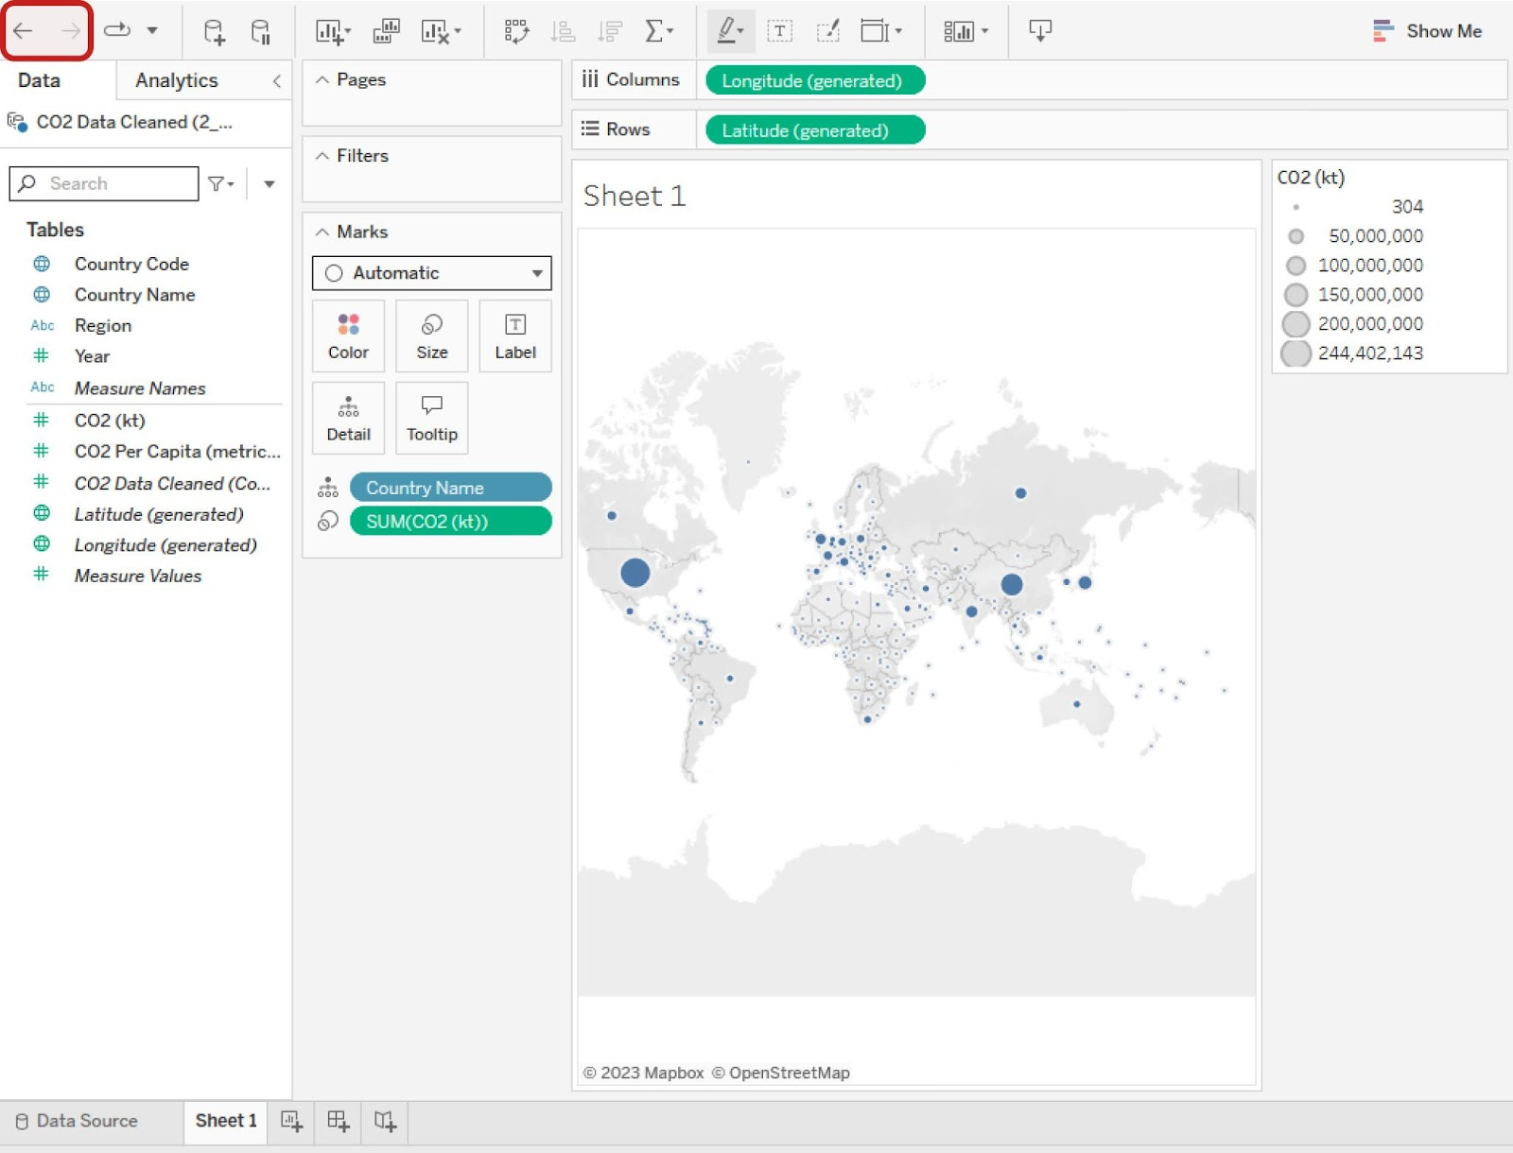

### **Change dimensions and measures**



Changing either the dimension or the measure on a chart is simple. Suppose that, instead of visualizing the CO2 per country, you want to chart the CO2 per capita per region. To do this, in the sidebar, double-click on the dimension Region. Then double-click on the measure CO2 Per Capita. This will result in seven world charts: East Asia & Pacific, Europe & Central Asia, Latin America & Caribbean, Middle East & North Africa, North America, South Asia, and Sub-Saharan Africa.

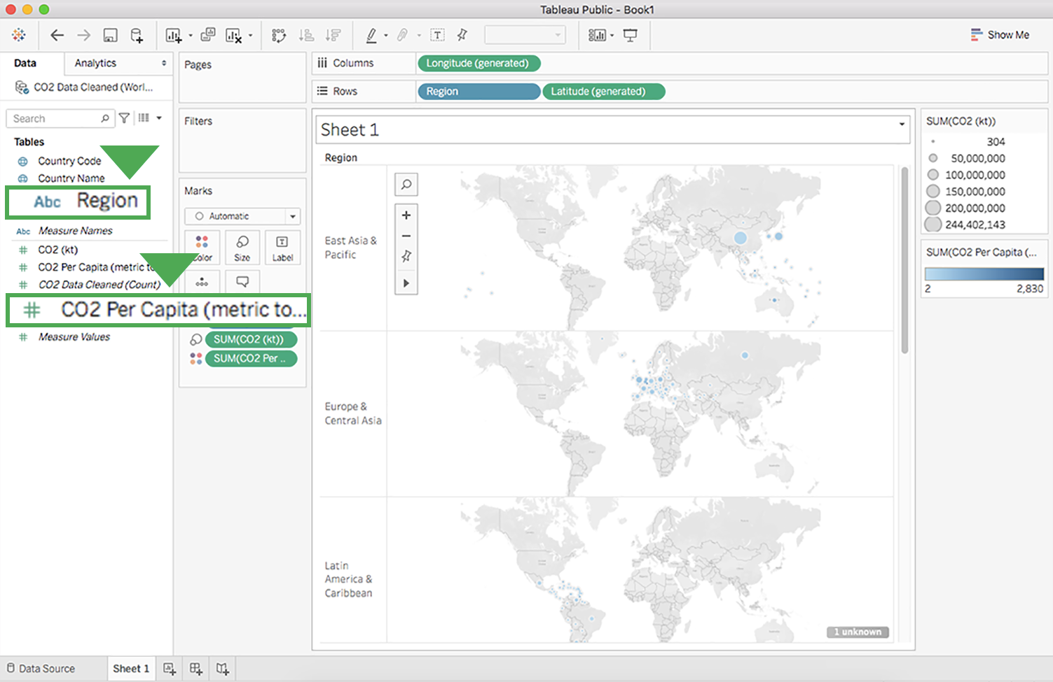

Just below this, under measure names, there is a callout box around CO2 per capita in metric tons.

### Step 7: Customize your chart's title

Currently, the title of this chart is Sheet 1. To give the chart a more descriptive title:

1. Point to the title box, select the dropdown list menu, and then select Edit Title to open the Edit Title dialog box. (You can also double-click Sheet 1 to open the Edit Title dialog box where you can change the title.)

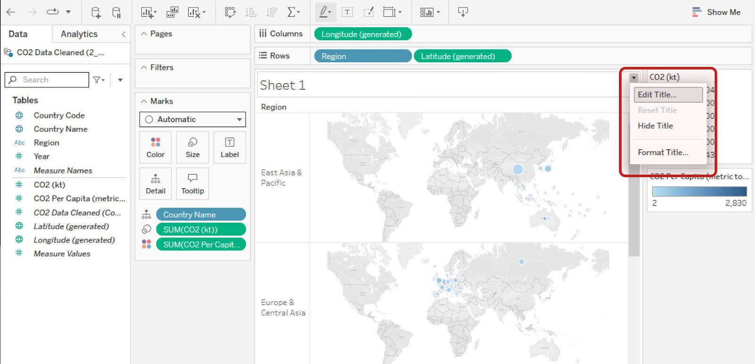

The menu includes options to Edit Title, Reset Title, Hide Title, and Format Title. Edit Title is highlighted.

2. Enter any title you wish and select OK. A descriptive title helps people understand what the chart visual seeks to convey. For example, you could title this chart “CO2 Per Capita by Region.”

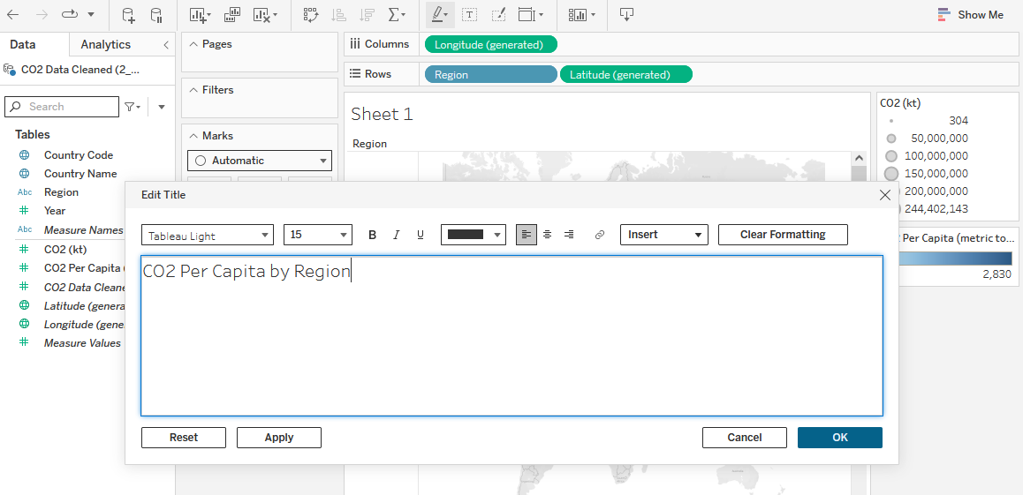

You can also choose to insert an object, or clear formatting. CO2 Per Capita by Region has been typed into the title field. Below four buttons allow you to Reset, Apply, Cancel, or OK

### Step 8: Delete a chart or sheet

### **Delete a chart**

To delete a chart from the sheet, select the Clear Sheet button in the toolbar.

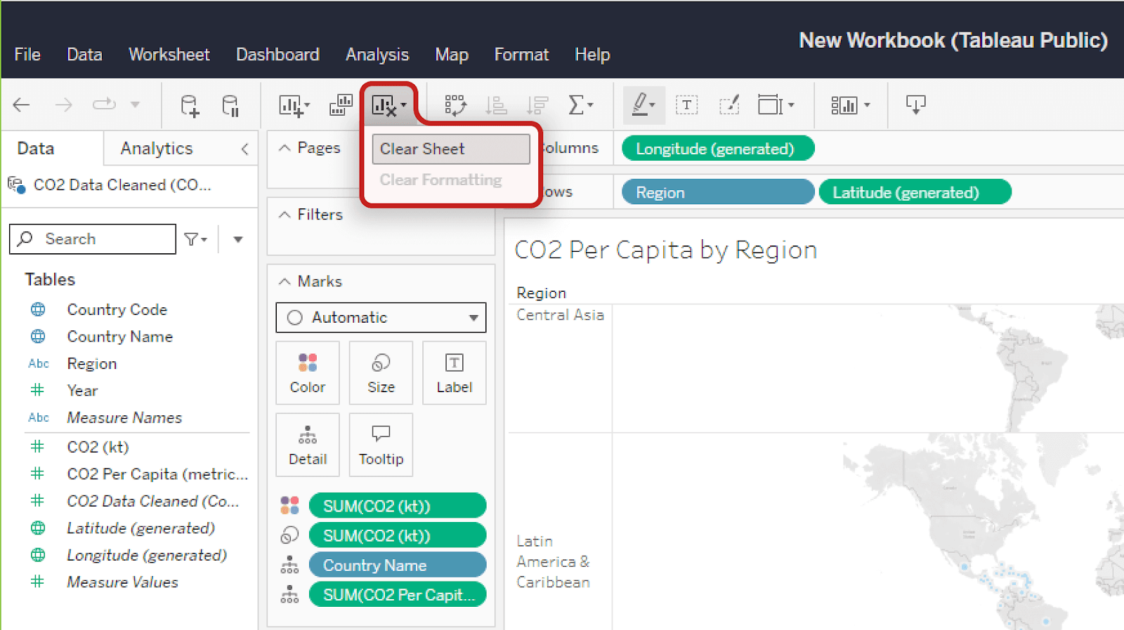

On this same dropdown menu, the clear formatting option is greyed out.]

This will completely delete the chart and bring you back to an empty sheet.

Note: This will not remove the sheet title.

If you delete a chart by accident or change your mind, select the Back button to undo the deletion.

### **Delete a sheet**

If you want to delete a sheet in its entirety, right-click on the sheet's tab at the bottom of the screen and select Delete. You won’t be able to delete a sheet if it is the only sheet in your file.

Note: Unlike clearing a sheet, deleting a sheet altogether cannot be reversed!

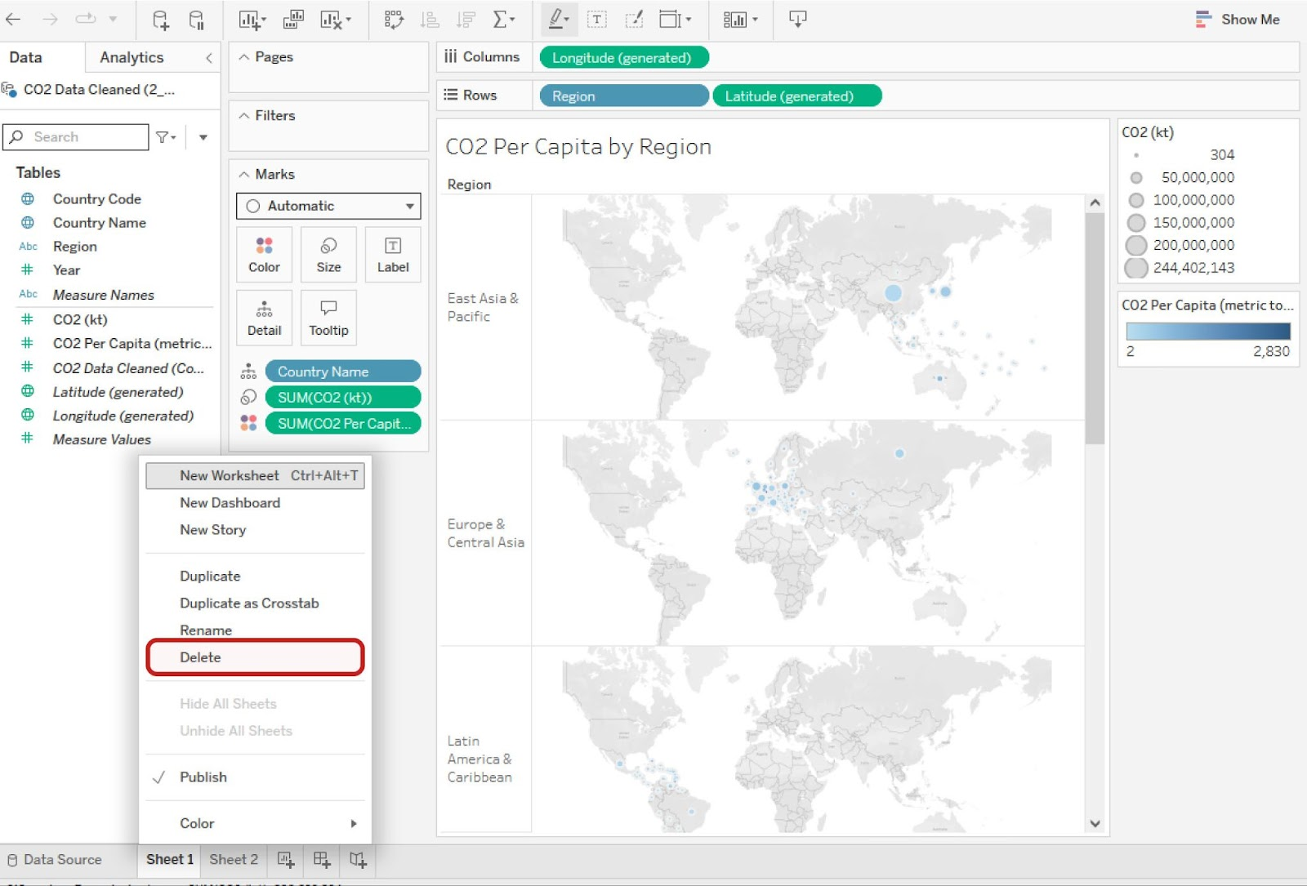

Menu choices include New Worksheet, New Dashboard, New Story, Duplicate, Duplicate as Crosstab, Rename, Delete, Hide All Sheets, Unhide All Sheets, Publish, and Color.

The skills you’ve practiced in this hands-on activity will help you get started visualizing your data. This is far from the end of the story, though. As you progress through this course, you’ll continue refining your Tableau skills.

[OPTIONAL: USING TABLEAU DESKTOP](https://www.coursera.org/learn/visualize-data/supplement/bMjvq/optional-using-tableau-desktop)

You have started exploring Tableau as a data visualization tool in business intelligence dashboards to convey insights with stakeholders. Throughout this program, you will continue to use and access Tableau—eventually using it to create your own dashboards. This reading will enable you to familiarize yourself with Tableau's interface and functionality.

## **Create a profile on Tableau Public**

With Tableau Public, you can create and share visualizations. If you don’t already have an account, make one on the [Tableau Public](https://public.tableau.com/s/) site. Note that trying to make an account from the main page will sign you up for a Tableau Free Trial rather than a Tableau Public account.

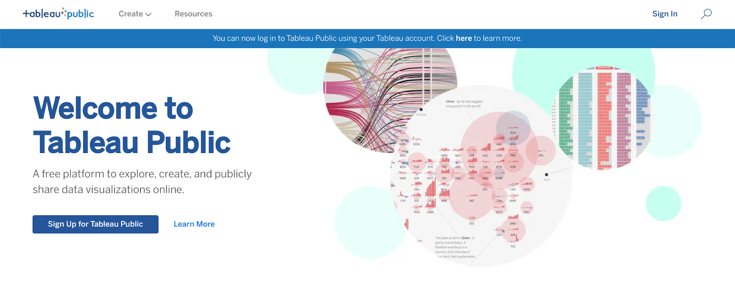

The difference between these two options is that a Free Trial lasts for 14 days, whereas Tableau Public gives you long-term access through the web version of the program. It has some limitations compared to the other versions of Tableau, but it is free to use and will enable you to complete the upcoming activities. You can also use your Tableau credentials to access Tableau Public if you already have an account! You are welcome to try the free trial or purchase Tableau, but it is not required for this program.

Complete the information in the signup form. When you click the **Create My Profile** button, you’ll be transferred to your profile page. This is where your Tableau Public visualizations can be made public to share with your peers. In the tabs on this page, you can access lists of visualizations you’ve made, visualizations you’ve favorited, authors you are following, and authors who are following you. By clicking **Edit Profile,** you can add additional information like your bio, title, organization, and links to social media accounts. This is also where you can enable Tableau Public’s **Hire Me** button. The **Hire Me** button will indicate to potential hiring managers that your Tableau skills are available for hire.

## **Optional: Download the desktop version**

With the desktop application, you can use features from Tableau Public without connecting to the internet. It is free to use, just like Tableau Public’s online version. Keep in mind that this application cannot be used on the Chromebook operating system and is not required for this course. If you are using Windows or Mac OS, this desktop application will enable you to complete upcoming activities that use Tableau Public. To download [Tableau Public Desktop Edition](https://www.tableau.com/products/public/download) (this is optional), log into your account and review the [system requirements](https://www.tableau.com/products/techspecs#public) for your operating system.

## **Loading and linking data**

Tableau enables you to load in your own data and link it to other datasets directly in the platform. When you log in, choose to **Create a Viz.** This will open a new worksheet where you can upload data or connect to online sources, such as your Google Drive.

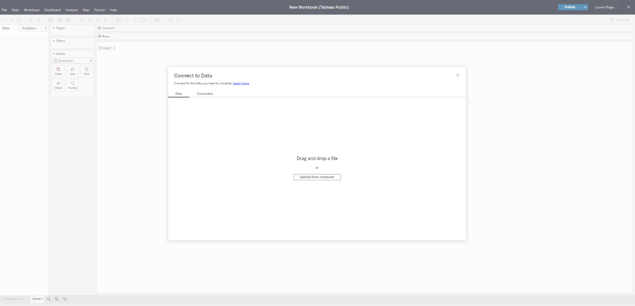

Once you upload data to your worksheet, it will populate the Connections pane.

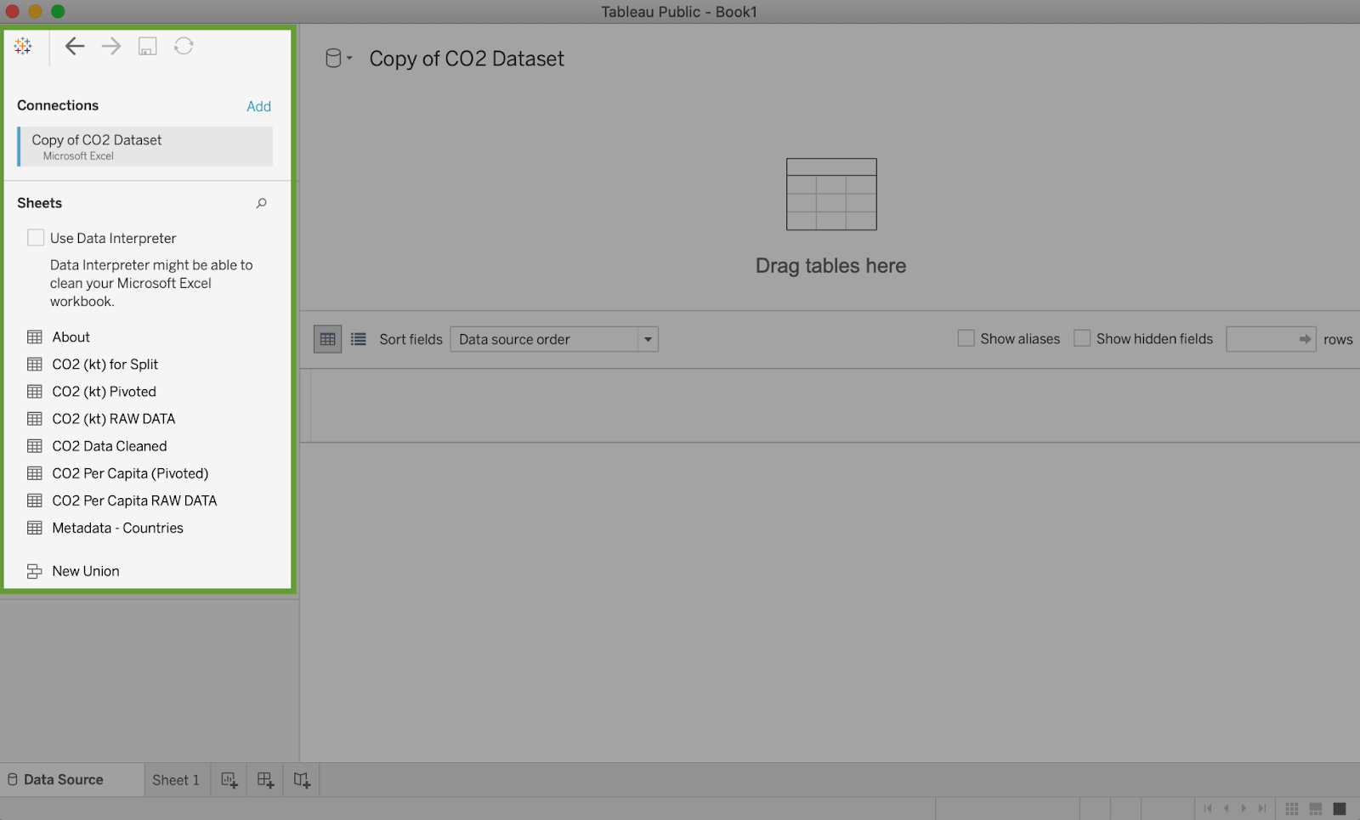

You can add more connections to other data sources in order to build visualizations that compare different datasets. Simply drag and drop tables from the Sheets section in order to join tables and generate those connections:

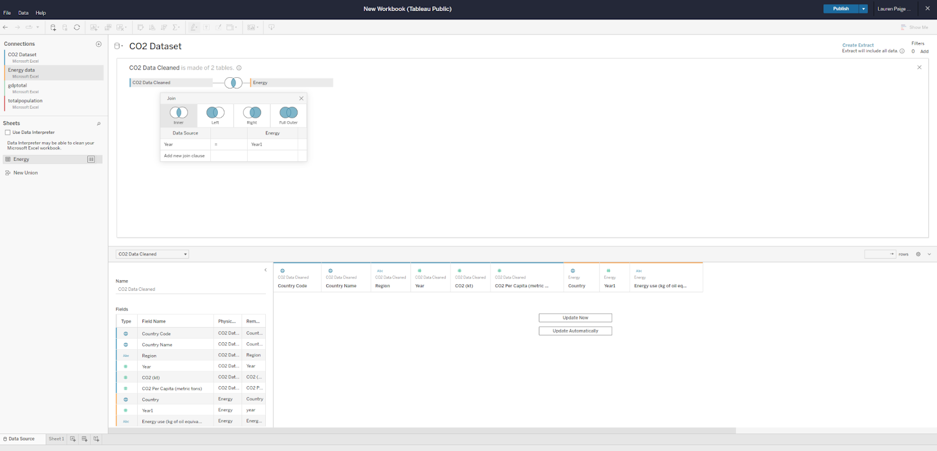

## **Dimensions and measures**

Tableau uses dimensions and measures to generate customized charts. For example, check out this chart focusing on CO2 emissions per country. The Country Name dimension can be used to show a map of the countries on the planet with dots indicating which countries are represented in the data.

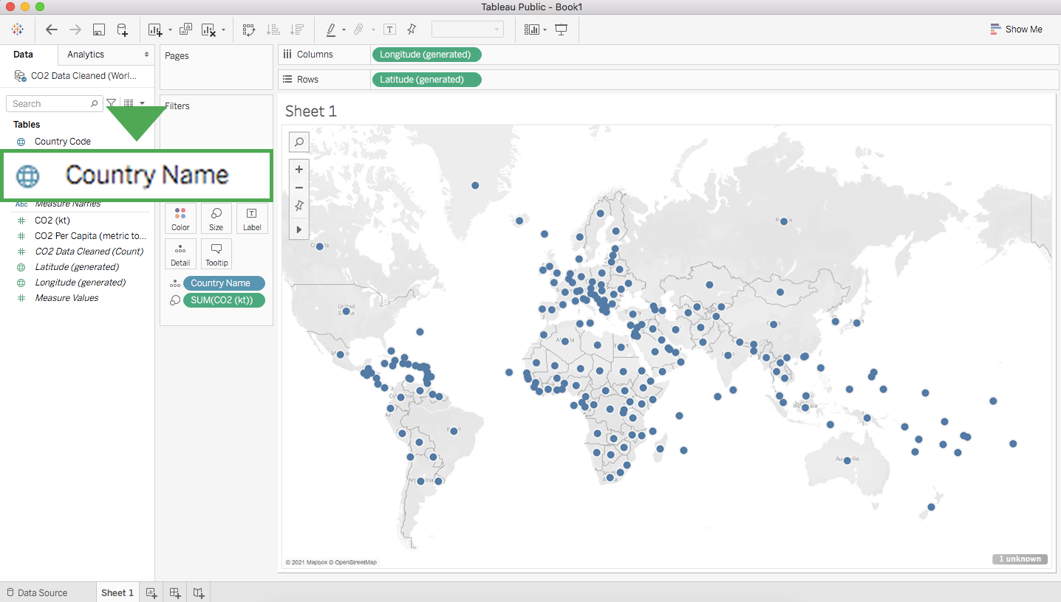

The dots are all the same size because—with no measure selected—Tableau defaults to scale each country equally. If you want to scale by CO2 emissions, you need to include a specific measure. Here is the same chart with a measure for CO2 kiloton (kt). This changes the size of the dots to be proportional to the amount of CO2 emitted:

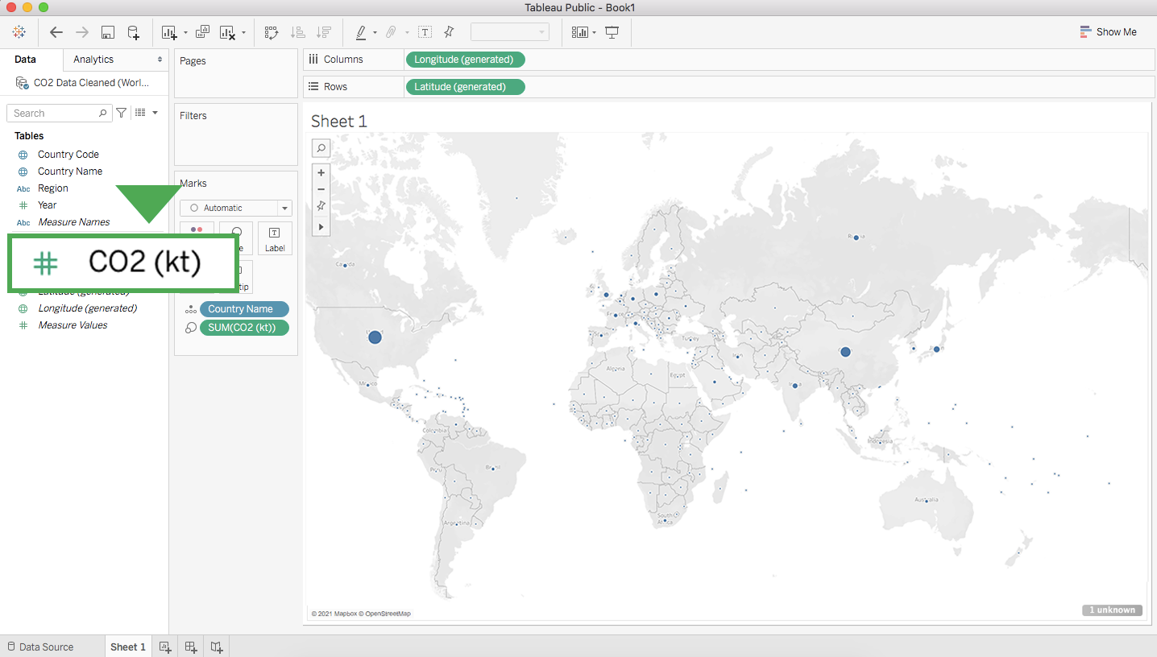

Tableau has a wide variety of options for depicting the measure for a given dimension. Most of these options are contained near the main display and the column with dimensions and measures.

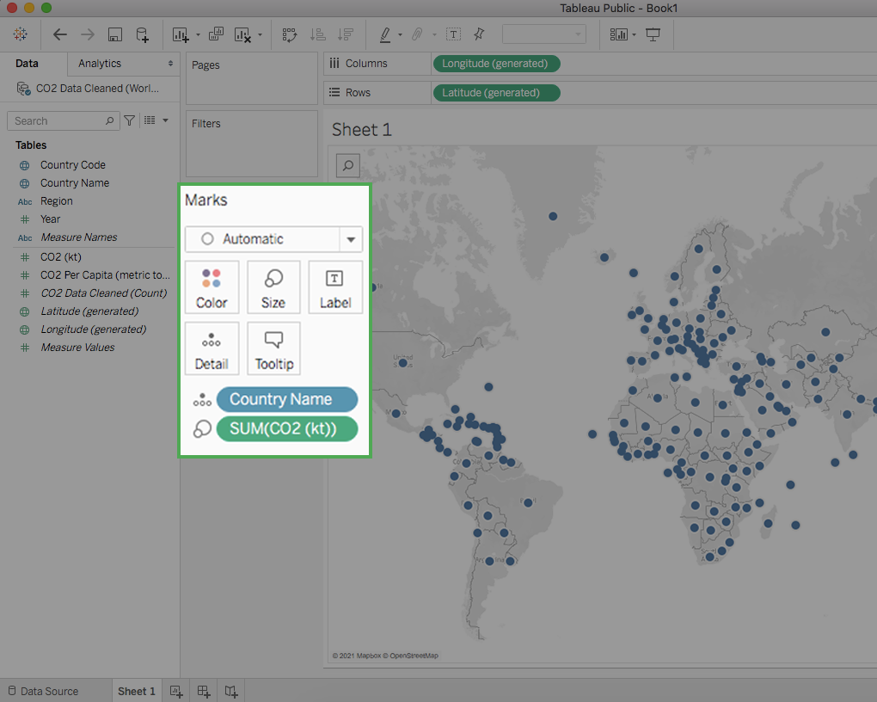

## **Key takeaways**

Tableau allows you to customize measures with options such as Color, Size, and Label, which change those aspects of the measure’s visualization on the chart. As you customize measures in Tableau, you will want to consider accessibility for your audience. As a refresher, you can check out [this video on accessible visualizations from the Google Data Analytics Certificate program.](https://www.coursera.org/learn/visualize-data/lecture/yVjKD/accessible-visualizations)

DESIGN VISUALIZATIONS IN TABLEAU

[OPTIMIZE THE COLOR PALETTE IN DATA VISUALIZATION](https://www.coursera.org/learn/visualize-data/lecture/zBZG7/optimize-the-color-palette-in-data-visualization)

In this video we'll take a closer look at effective and ineffective data visualizations using Tableau. That's right. Even though this platform can help you create some really beautiful visuals, all of those features and functions can lead to something that's just not very useful too.

You might remember the five second rule we spoke about earlier. **A sign of a good data visualization is that once you show it to an audience, they should understand what you're trying to convey within five seconds**. This means it's c**lear, effective, and most importantly, convincing**. If you keep that rule of thumb in mind before you begin any Tableau Viz, you'll be on the right path to creating good visuals.

Let's take a look at an example of a good use of a diverging color palette. A diverging color palette displays two ranges of values using color intensity to show the magnitude of the number and the actual color to show which range the numbers from.

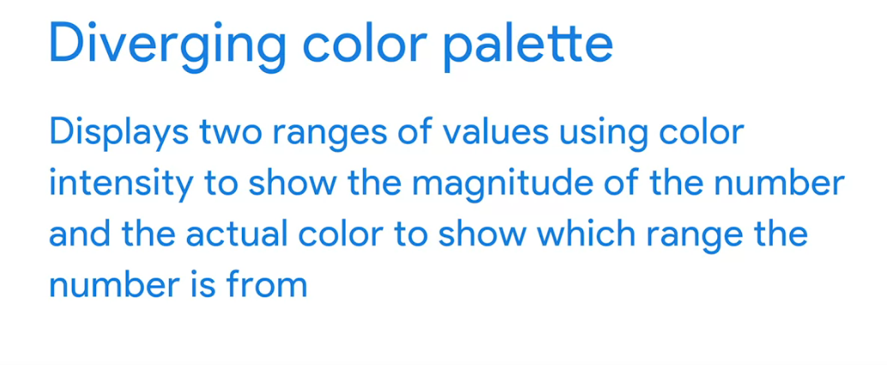

It's a good way to show the difference between numbers. Here, green is associated with higher numbers and red with lower numbers.

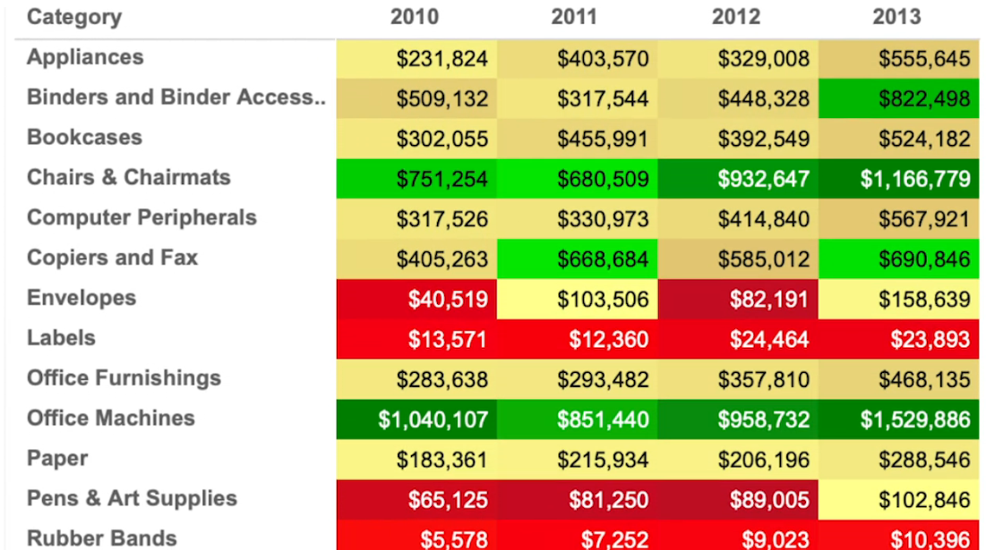

You may come across tables like this as it relates to business metrics and KPIs. The colors you choose should fit within the scope of the audience's expectations. While this might not always be true globally, a lot of people associate green with positive and red with negative. This makes things nice and clear.

Here's an ineffective data Viz example.

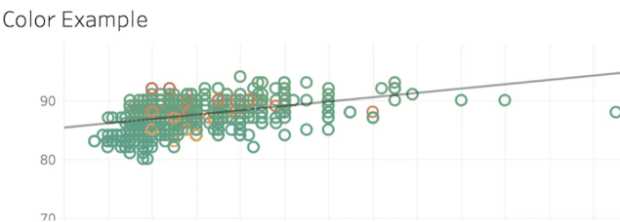

There's a lot about this Viz isn't working well, but these colors are hard to read. This graph uses green and orange and the data points are really close together. These colors don't clearly show the difference between low and high data points. Data visualization allows us to share meaningful stories about data, but we can't do it if it's too hard for the audience to understand the data Viz were sharing. Using color pairings that don't fit your audience's expectations could add another layer of unnecessary complexity.

Brace yourself because there's another way to make an ineffective data visualization even worse. If you add a few too many labels, you end up with a data visualization that's really hard to take in.

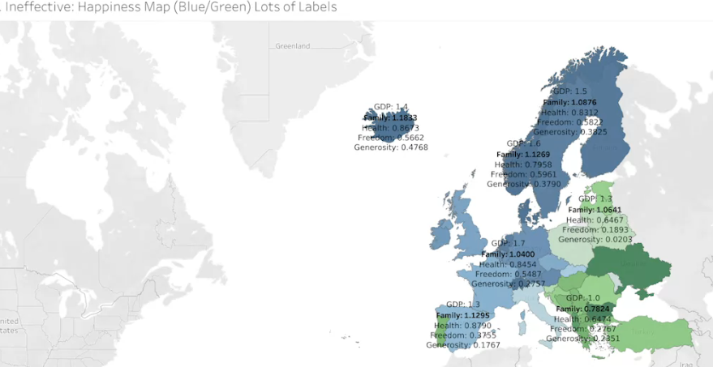

Doing this makes the visualization too busy. It takes up too much space and it prevents the labels from being clearly shown. All of this is made worse by using different fonts across the labels. What we have here is good data that turns bad because of the visuals. Having an interactive visualization can be useful for both your audience and for you as the analyst. But just like anything else, the more power you have, the more responsibility you have. Lose sight of the qualities of a good viz and you can lose control over the story you want the data to tell. Now that you learned how to use visual enhancements to your advantage. Next up, we'll check out ways you can get even more creative with them.

[ESSENTIAL DESIGN PRINCIPLES](https://www.coursera.org/learn/visualize-data/supplement/n30Nd/essential-design-principles)

You recently learned about pre-attentive attributes of data visualization—the building blocks of data visualizations: marks and channels. In this reading, you’ll take this understanding a step further with essential design principles.

As an analyst, your audiences will have a variety of roles, backgrounds, and perspectives. You might present information to other data analysts, to clients, or to executives in your company’s C-suite. You’re responsible for developing data visualizations that convey the information your audience needs in a manner that makes sense to everyone.

## 

## **Design principles**

These design principles are important to your work as a data analyst because they help ensure that you’re creating visualizations that communicate your data effectively to your audience. By keeping these rules in mind, you can plan and evaluate your data visualizations to decide if they’re working. And, if they aren’t, you can adjust them!

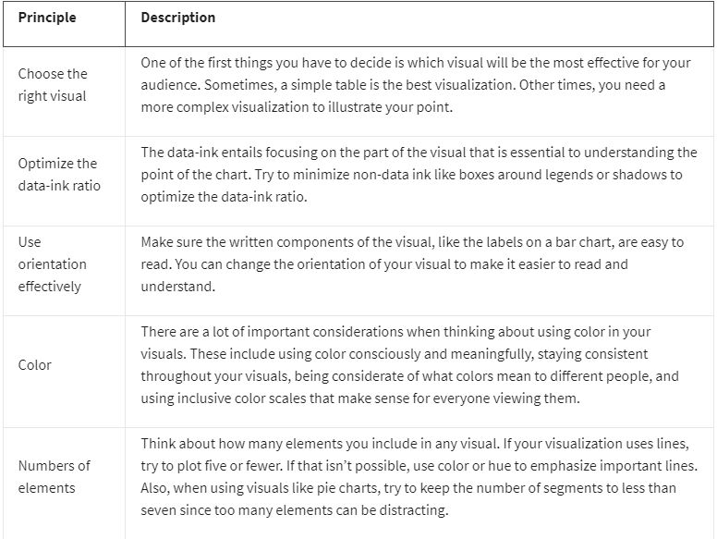

**Avoiding misleading or deceptive charts**

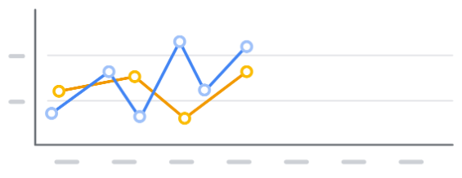

As you are considering what kind of visualization to create and how to design it, you will also want to be sure that you are not creating misleading or deceptive charts. Data analysis provides insights and knowledge that people use to make decisions. So, it’s important that the visualizations you create are communicating data insights accurately and truthfully.

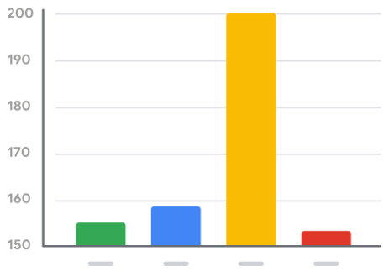

Here are some common errors to avoid so that your visualizations aren’t accidentally misleading:

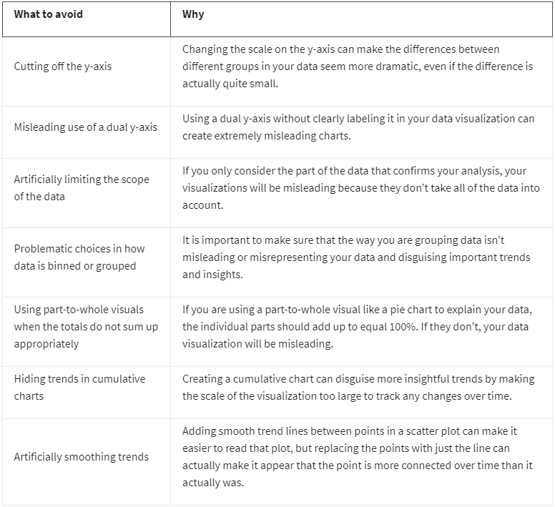

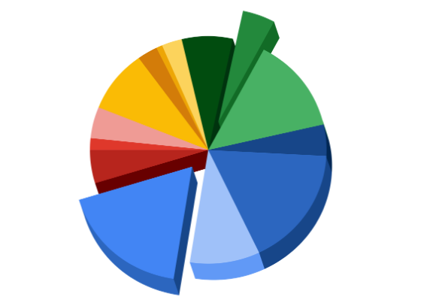

## **Key takeaways**

Design principles are important for creating effective data visualizations. When creating visualizations, consider the audience, choose the right visual for the job, and be sure to avoid misleading or deceptive visuals. By following these principles, you’ll be able to design visualizations that are effective, informative, and easy to understand, which will help you communicate findings to a wider audience and make a greater impact on your organization!

[MISLEADING VISUALIZATIONS](https://www.coursera.org/learn/visualize-data/discussionPrompt/4xtIo/misleading-visualizations)

You can create data visualizations in Tableau using a wide variety of charts, colors, and styles. And you have tremendous freedom in the tool to decide how these visualizations will look and how they will present your data.

Below is an example of a visualization created in Tableau:

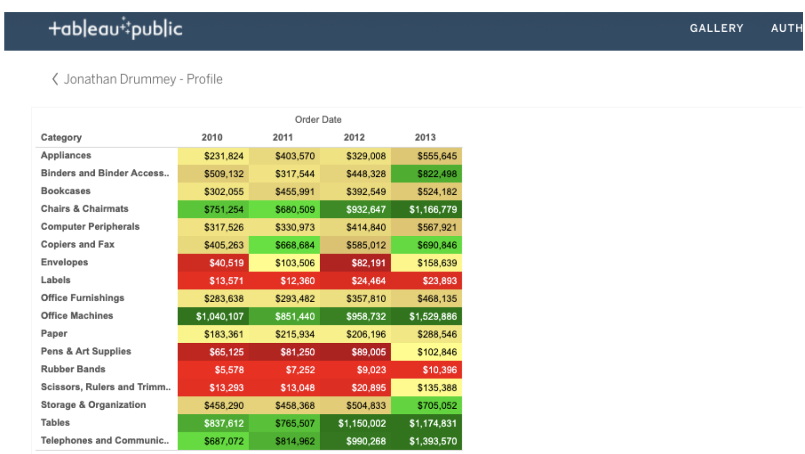

Study the visualization and think about these questions:

* Red normally indicates danger or a warning. Why do you think cells are highlighted in red?
* Green normally indicates a positive or “go” status. Is it clear why certain cells are highlighted in green?
* The purpose of the color coding isn’t clear without a legend, but can you guess what might have been the intent?

Post your theory of what the colors mean. In the same post, share in 3-5 sentences (150-200 words) how this table could be misleading and how you would improve it to avoid confusion.

Then, visit the [discussion forum](https://www.coursera.org/learn/visualize-data/discussions) to browse what other learners shared and engage in at least two discussions about the visualization.

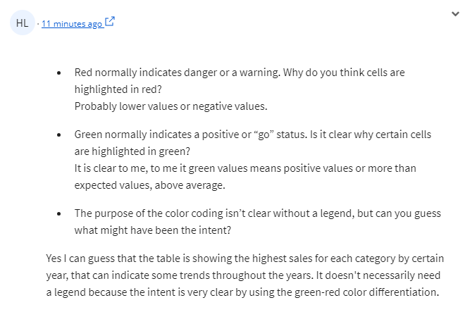[BONUS GUIDE: ADDITIONAL INSIGHTS ON SELECTING THE RIGHT DATA VISUALIZATION](https://www.coursera.org/learn/visualize-data/supplement/jQwMR/bonus-guide-additional-insights-on-selecting-the-right-data-visualization)

In addition to the content in this course, Google has a helpful guide on choosing which type of data visualization works best for your needs. Note that this optional guide includes some primary chart types; there are many other charts and chart variations not shown in the table. If your data matches more than one description, you can also create acombo chart that combines more than one visualization type.

**Download the guide:**

[How to choose a data visualization.pdf](https://d3c33hcgiwev3.cloudfront.net/XsaUfemhQ-qGlH3poXPqMg_4b74b6280a7a4a10a83e6b5ca9138630_How-to-choose-a-data-visualization.pdf?Expires=1715385600&Signature=cFktI-JmP~MIBkU3rZn8OFwOXP0KGOKdPEuS34JWCD1z1Vf7dSof6oIsdpknygjInnBJ63KS0~-Ce90doINwSggoYS5~djPNZaGWwVmf9LT8tQXqk~ntL4cFqlYopfCNViF6lOxDq-pszDM6qJUY0M-8jEeEKpbX9yManulMf48_&Key-Pair-Id=APKAJLTNE6QMUY6HBC5A)

[SELF-REFLECTION: SELECT VISUALS AND CHARTS](https://www.coursera.org/learn/visualize-data/quiz/ud0AO/self-reflection-select-visuals-and-charts)



## **Activity Overview**



Now that you have learned about different kinds of visualizations, you can pause for a moment and think about what you are learning. In this self-reflection, you will consider how to select the right visualization for your needs and respond to brief questions.

This self-reflection will help you develop insights into your own learning and prepare you to apply your knowledge of visualizations to your own projects. As you answer questions—and come up with questions of your own—you will consider concepts, practices, and principles to help refine your understanding and reinforce your learning. You’ve done the hard work, so make sure to get the most out of it: This reflection will help your knowledge stick!

### 

### Understand what makes an effective visualization

The key to effective presentations is data visualizations that are clear and convincing. In turn, the key to effective visualizations is selecting the best way to depict your data.

You have learned about a few types of visualizations (e.g., bar graphs, pie charts) and what each type is best at emphasizing. Determining which type of visualization to use is essential to giving your presentation the impact it needs.

So far, you have considered a few rules about what makes a helpful data visualization:

* Five-second rule: A data visualization should be clear, effective, and convincing enough to be absorbed in five seconds or less.
* Color contrast: Graphs and charts should use a diverging color palette to show contrast between elements.
* Conventions and expectations: Visuals and their organization should align with audience expectations and cultural conventions. For example, if the majority of your audience associates green with a positive concept and red with a negative one, your visualization should reflect this.
* Minimal labels: Titles, axes, and annotations should use as few labels as it takes to make sense. Having too many labels makes your graph or chart too busy. It takes up too much space and prevents the labels from being shown clearly.

For a refresher, you can refer back to the readings from this section. Check out [Designing a chart in 60 minutes](https://www.coursera.org/learn/visualize-data/supplement/IcuWb/dac6m1l4r2-designing-a-chart-in-60-minutes), [The wonderful world of visualizations](https://www.coursera.org/learn/visualize-data/supplement/j9Wdl/dac6m1l4-the-wonderful-world-of-visualizations), and [Visualizations in spreadsheets and Tableau](https://www.coursera.org/learn/visualize-data/supplement/bDdpK/dac6m2l2r3-visualizations-in-spreadsheets).

### 

### **Reflection**

Consider the guidelines for picking a visualization that you reviewed in this reflection:

* What should you consider when deciding on the right data visualization?  
    
  You should check the type of data you have, consider the size of your data, consider your public and its particularities and what type of visualization would be the best match for the data you have.
* What is your first step in determining the best data visualization for a presentation?  
    
  I'd say it's to check who will be my audience..

[GET CREATIVE](https://www.coursera.org/learn/visualize-data/lecture/Eytgs/get-creative)

Hey, good to see you again. One of my favorite aspects of data visualizations is how creative it lets me be.

You might remember me saying earlier that data viz the intersection of art and analytics, and it really is. I'm here to help you find your inner kid with a crayon from turning messy charts into effective ones to making your visuals more accessible to people who have color vision deficiencies.

It's time to explore how your creativity can help you get the most out of your data. Jump right in by signing into your Tableau account, we'll return to our world Happiness Data in the Google Career Certificates Page. Click this [LINK](https://public.tableau.com/profile/grow.with.google#!/) to Open the gallery, now click to view the workbook titled Just the Data: World Happiness.

We use the same workbook in the earlier video about getting started with Tableau. Let's click up here to get started. Let's say we want to use this data in this table to figure out what the biggest contributors to a country's happiness score are.

We'll start by digging into the relationship between happiness scores and the other country measures to see what we can find. To start, create a new worksheet to build your own data viz from scratch, you'll click on worksheet and then new worksheet. Since our data has three years of values, let's filter to 2016.

To do this, add year to the filter shelf and choose 2016. Add happiness score to the rows shelf. Then add economy GDP per capita to the column shelf.

Next drag and drop country to the detail section, this creates a separate circle or data point for each country. You might notice that where the economy scores higher, the happiness scores also higher.

To make this trend easier to see, let's add a trend line.

Now duplicate this sheet so that all of your formatting stays the same. In the duplicate sheet replace economy GDP per capita with another measure such as family. Drag the family table into the column shelf to replace the economy. We'll rename our original tab economy.

And this new tab family, so that we can easily recognize what they show and find them when we need. Try doing this for more of the measures. Now let's show what multiple visualizations on a single dashboard look like, so you can more easily see the relationship between them. Drag your visualizations, which are now listed on the left tables column one at a time to populate the dashboard. They could be arranged in different ways, take note of which trend lines have the steepest incline. Those are the ones with the strongest relationship, the happiness score. Each chart should have an easily understood purpose that's immediately clear to your audience, and that's just what this does. You can also add a companion table, which shows the same data in a different way in case people in your audience prefer tables. In my experience, some stakeholders prefer to see their data in spreadsheets. We've been spending a lot of time using one data source, but you'll likely end up juggling more than one data set at a time as an analyst.

Coming up, you'll have the option to learn more about combining multiple data sources in Tableau bye for now.

[TEST YOUR KNOWLEDGE ON CREATING VISUALIZATIONS IN TABLEAU](https://www.coursera.org/learn/visualize-data/quiz/E9xV8/test-your-knowledge-on-creating-visualizations-in-tableau)

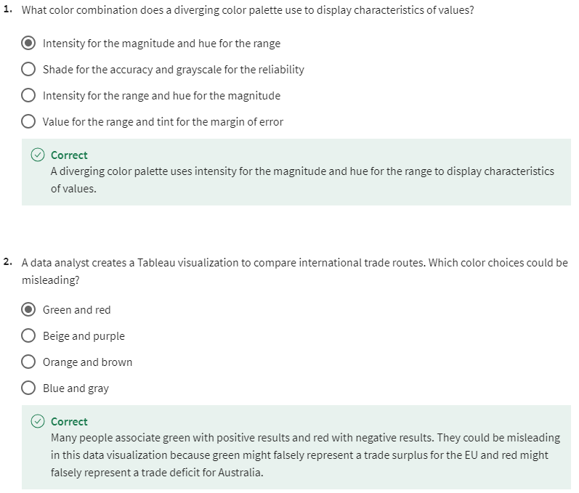

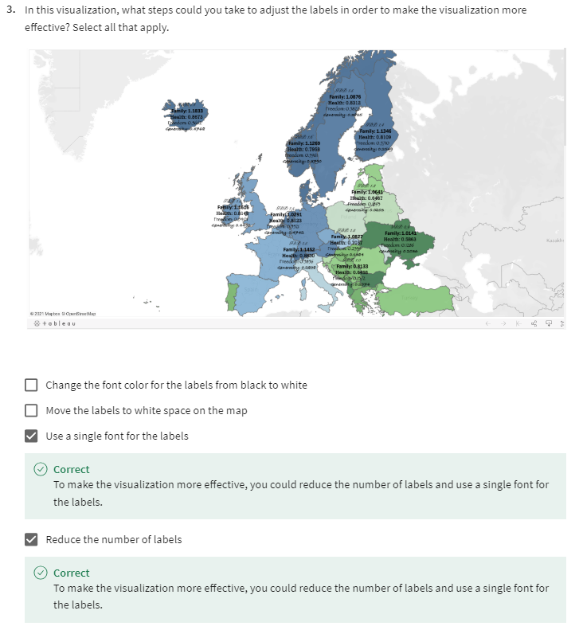

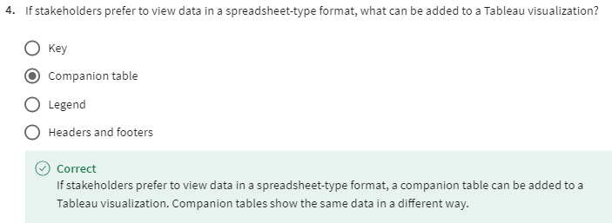

OPTIONAL: WORK WITH MULTIPLE DATA SOURCES

[LINK MULTIPLE DATASETS IN TABLEAU](https://www.coursera.org/learn/visualize-data/lecture/C4Avg/link-multiple-datasets-in-tableau)

[HANDS-ON ACTIVITY: LINK MULTIPLE DATASETS IN TABLEAU](https://www.coursera.org/learn/visualize-data/quiz/ePEB4/hands-on-activity-link-multiple-datasets-in-tableau)

[TABLEAU RESOURCES FOR COMBINING MULTIPLE DATA SOURCES](https://www.coursera.org/learn/visualize-data/supplement/mx5BE/tableau-resources-for-combining-multiple-data-sources)

M2 CHALLENGE

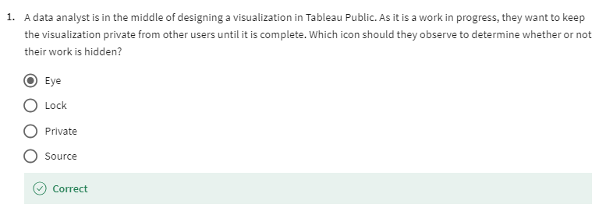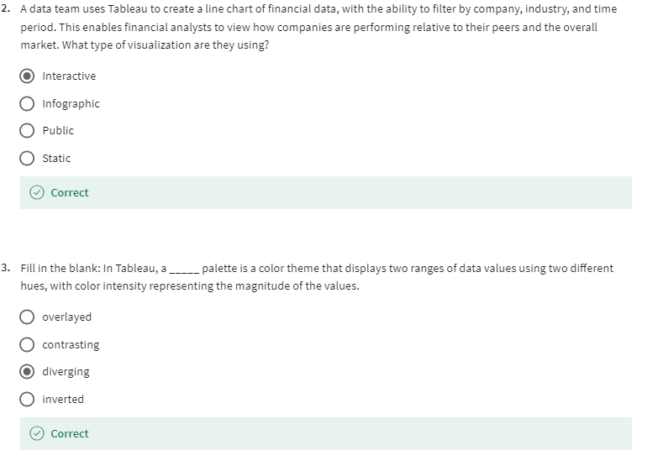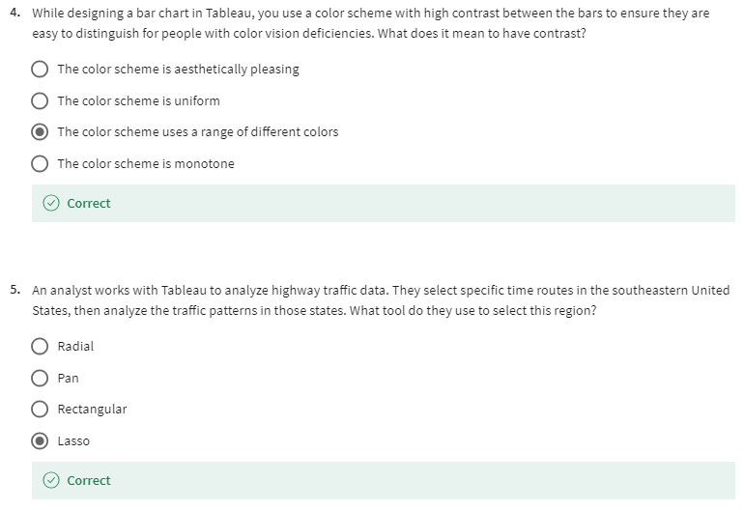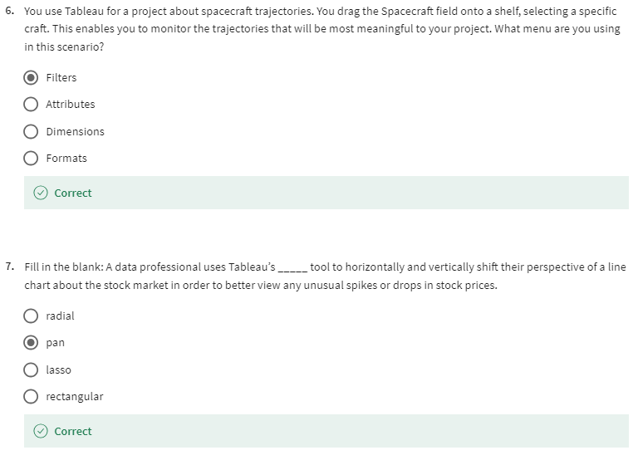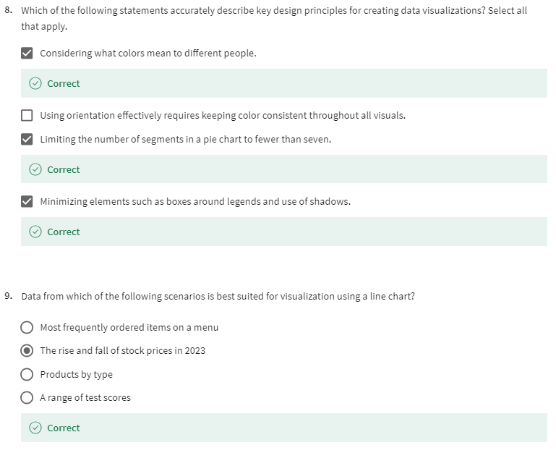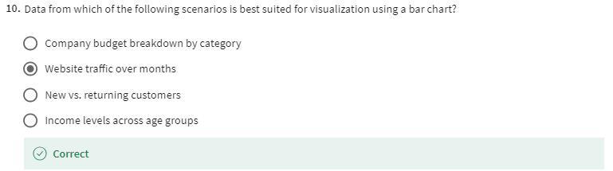

[GLOSSARY TERMS FROM MODULE 2](https://www.coursera.org/learn/visualize-data/supplement/hd0z5/glossary-terms-from-module-2)

## **Terms and definitions for Course 6, Module 2**

**Area chart**:A data visualization that uses individual data points for a changing variable connected by a continuous line with a filled in area underneath

**Box plot:** A data visualization that displays the distribution of values along an x-axis

**Bubble chart**: A data visualization that displays individual data points as bubbles, comparing numeric values by their relative size

**Bullet graph:** A data visualization that displays data as a horizontal bar chart moving toward a desired value

**Circle view:** A data visualization that shows comparative strength in data

**Column chart**: A data visualization that uses individual data points for a changing variable, represented as vertical columns

**Combo chart:** A data visualization that combines more than one visualization type

**Density map**: A data visualization that represents concentrations, with color representing the number or frequency of data points in a given area on a map

**Distribution graph:** A data visualization that displays the frequency of various outcomes in a sample

**Diverging color palette:** A color theme that displays two ranges of data values using two different hues, with color intensity representing the magnitude of the values

**Donut chart**: A data visualization where segments of a ring represent data values adding up to a whole

**Filled map:** A data visualization that colors areas in a map based on measurements or dimensions

**Gantt chart:** A data visualization that displays the duration of events or activities on a timeline

**Gauge chart**: A data visualization that shows a single result within a progressive range of values

**Highlight table:** A data visualization that uses conditional formatting and color on a table

**Packed bubble chart:** A data visualization that displays data in clustered circles

**Symbol map:** A data visualization that displays a mark over a given longitude and latitude

# 

# 

# **Terms and definitions from previous modules**

### **A**

**A/B testing:** The process of testing two variations of the same web page to determine which page is more successful at attracting user traffic and generating revenue

**Absolute reference:** A reference within a function that is locked so that rows and columns won’t change if the function is copied

**Access control:** Features such as password protection, user permissions, and encryption that are used to protect a spreadsheet

**Accuracy:** The degree to which data conforms to the actual entity being measured or described

**Action-oriented question:** A question whose answers lead to change

**Administrative metadata:** Metadata that indicates the technical source of a digital asset

**Agenda**: A list of scheduled appointments

**Aggregation:** The process of collecting or gathering many separate pieces into a whole

**Algorithm:** A process or set of rules followed for a specific task

**Aliasing:** Temporarily naming a table or column in a query to make it easier to read and write

**Alternative text:** Text that provides an alternative to non-text content, such as images and videos

**Analytical skills:** Qualities and characteristics associated with using facts to solve problems

**Analytical thinking:** The process of identifying and defining a problem, then solving it by using data in an organized, step-by-step manner

**Annotation:** Text that briefly explains data or helps focus the audience on a particular aspect of the data in a visualization

**Array:** A collection of values in spreadsheet cells

**Attribute**: A characteristic or quality of data used to label a column in a table

**Audio file:** Digitized audio storage usually in an MP3, AAC, or other compressed format

**AVERAGE**: A spreadsheet function that returns an average of the values from a selected range

**AVERAGEIF:** A spreadsheet function that returns the average of all cell values from a given range that meet a specified condition

### **B**

**Bad data source:** A data source that is not reliable, original, comprehensive, current, and cited (ROCCC)

**Balance:** The design principle of creating aesthetic appeal and clarity in a data visualization by evenly distributing visual elements

**Bar graph:** A data visualization that uses size to contrast and compare two or more values

**Bias:** A conscious or subconscious preference in favor of or against a person, group of people, or thing

**Big data:** Large, complex datasets typically involving long periods of time, which enable data analysts to address far-reaching business problems

**Boolean data:** A data type with only two possible values, usually true or false

**Borders**: Lines that can be added around two or more cells on a spreadsheet

**Business task:** The question or problem data analysis resolves for a business

### **C**

**Calculated field:** A new field within a pivot table that carries out certain calculations based on the values of other fields

**Calculus:** A branch of mathematics that involves the study of rates of change and the changes between values that are related by a function

**CASE:** A SQL statement that returns records that meet conditions by including an if/then statement in a query

**CAST:** A SQL function that converts data from one datatype to another

**Causation:** When an action directly leads to an outcome, such as a cause-effect relationship

**Cell reference:** A cell or a range of cells in a worksheet typically used in formulas and functions

**Changelog:** A file containing a chronologically ordered list of modifications made to a project

**Channel:** A visual aspect or variable that represents characteristics of the data in a visualization

**Chart:** A graphical representation of data from a worksheet

**Clean data:** Data that is complete, correct, and relevant to the problem being solved

**Cloud:** A place to keep data online, rather than a computer hard drive

**Cluster:** A collection of data points on a data visualization with similar values

**COALESCE:** A SQL function that returns non-null values in a list

**Compatibility:** How well two or more datasets are able to work together

**Completeness:** The degree to which data contains all desired components or measures

**CONCAT:** A SQL function that adds strings together to create new text strings that can be used as unique keys

**CONCATENATE:** A spreadsheet function that joins together two or more text strings

**Conditional formatting:** A spreadsheet tool that changes how cells appear when values meet specific conditions

**Confidence interval:** A range of values that conveys how likely a statistical estimate reflects the population

**Confidence level:** The probability that a sample size accurately reflects the greater population

**Confirmation bias:** The tendency to search for or interpret information in a way that confirms pre-existing beliefs

**Consent:** The aspect of data ethics that presumes an individual’s right to know how and why their personal data will be used before agreeing to provide it

**Consistency:** The degree to which data is repeatable from different points of entry or collection

**Context:** The condition in which something exists or happens

**Continuous data:** Data that is measured and can have almost any numeric value

**CONVERT:** A SQL function that changes the unit of measurement of a value in data

**Cookie:** A small file stored on a computer that contains information about its users

**Correlation:** The measure of the degree to which two variables change in relationship to each other

**COUNT**: A spreadsheet function that counts the number of cells in a range

**COUNTA:** A spreadsheet function that counts the total number of values within a range that meet specified criteria

**COUNTIF:** A spreadsheet function that returns the number of cells in a range that match a specified value

**COUNT DISTINCT:** A SQL function that only returns the distinct values in a specified range

**CREATE TABLE:** A SQL clause that adds a temporary table to a database that can be used by multiple people

**Cross-field validation:** A process that ensures certain conditions for multiple data fields are satisfied

**CSV (comma-separated values) file:** A delimited text file that uses a comma to separate values

**Currency:** The aspect of data ethics that presumes individuals should be aware of financial transactions resulting from the use of their personal data and the scale of those transactions

### **D**

**Dashboard:** A tool that monitors live, incoming data

**Data:** A collection of facts

**Data aggregation:** The process of gathering data from multiple sources and combining it into a single, summarized collection

**Data analysis:** The collection, transformation, and organization of data in order to draw conclusions, make predictions, and drive informed decision-making

**Data analysis process:** The six phases of ask, prepare, process, analyze, share, and act whose purpose is to gain insights that drive informed decision-making

**Data analyst:** Someone who collects, transforms, and organizes data in order to draw conclusions, make predictions, and drive informed decision-making

**Data analytics:** The science of data

**Data anonymization:** The process of protecting people's private or sensitive data by eliminating identifying information

**Data bias:** When a preference in favor of or against a person, group of people, or thing systematically skews data analysis results in a certain direction

**Data composition:** The process of combining the individual parts in a visualization and displaying them together as a whole

**Data constraints:** The criteria that determine whether a piece of a data is clean and valid

**Data design:** How information is organized

**Data-driven decision-making:** Using facts to guide business strategy

**Data ecosystem:** The various elements that interact with one another in order to produce, manage, store, organize, analyze, and share data

**Data element:** Apiece of information in a dataset

**Data engineer:** A professional who transforms data into a useful format for analysis and gives it a reliable infrastructure

**Data ethics:** Well-founded standards of right and wrong that dictate how data is collected, shared, and used

**Data governance:** A process for ensuring the formal management of a company’s data assets

**Data-inspired decision-making:** Exploring different data sources to find out what they have in common

**Data integrity:** The accuracy, completeness, consistency, and trustworthiness of data throughout its life cycle

**Data interoperability:** The ability to integrate data from multiple sources and a key factor leading to the successful use of open data among companies and governments

**Data life cycle:** The sequence of stages that data experiences, which include plan, capture, manage, analyze, archive, and destroy

**Data manipulation:** The process of changing data to make it more organized and easier to read

**Data mapping:** The process of matching fields from one data source to another

**Data merging:** The process of combining two or more datasets into a single dataset

**Data model:** A tool for organizing data elements and how they relate to one another

**Data privacy:** Preserving a data subject’s information any time a data transaction occurs

**Data range:** Numerical values that fall between predefined maximum and minimum values

**Data replication:** The process of storing data in multiple locations

**Data science:** A field of study that uses raw data to createnew ways of modeling and understanding the unknown

**Data security:** Protecting data from unauthorized access or corruption by adopting safety measures

**Data strategy:** The management of the people, processes, and tools used in data analysis

**Data transfer:** The process of copying data from a storage device to computer memory or from one computer to another

**Data type:** An attribute that describes a piece of data based on its values, its programming language, or the operations it can perform

**Data validation:** A tool for checking the accuracy and quality of data

**Data validation process:** The process of checking and rechecking the quality of data so that it is complete, accurate, secure and consistent

**Data visualization:** The graphical representation of data

**Data warehousing specialist:** A professional who develops processes and procedures to effectively store and organize data

**Database:** A collection of data stored in a computer system

**Dataset:** A collection of data that can be manipulated or analyzed as one unit

**DATEDIF:** A spreadsheet function that calculates the number of days, months, or years between two dates

**Decision tree**: A tool that helps analysts make decisions about critical features of a visualization

**Delimiter:** A character that indicates the beginning or end of a data item

**Descriptive metadata:** Metadata that describes a piece of data and can be used to identify it at a later point in time

**Design thinking:** A process used to solve complex problems in a user-centric way

**Digital photo:** An electronic or computer-based image usually in BMP or JPG format

**Dirty data:** Data that is incomplete, incorrect, or irrelevant to the problem to be solved

**Discrete data:** Data that is counted and has a limited number of values

**DISTINCT:** A keyword that is added to a SQL SELECT statement to retrieve only non-duplicate entries

**Distribution graph:** A data visualization that displays the frequency of various outcomes in a sample

**DROP TABLE:** A SQL clause that removes a temporary table from a database

**Duplicate data:** Any record that inadvertently shares data with another record

**Dynamic visualizations:** Data visualizations that are interactive or change over time

### **E**

**Emphasis:** The design principle of arranging visual elements to focus the audience’s attention on important information in a data visualization

**Equation:** A calculation that involves addition, subtraction, multiplication, or division (also called a math expression)

**Estimated response rate**: The average number of people who typically complete a survey

**Ethics:** Well-founded standards of right and wrong that prescribe what humans ought to do, usually in terms of rights, obligations, benefits to society, fairness, or specific virtues

**Experimenter bias:** The tendency for different people to observe things differently (Refer to Observer bias)

**External data:** Data that lives, and is generated, outside of an organization

### **F**

**Fairness:** A quality of data analysis that does not create or reinforce bias

**Field:** A single piece of information from a row or column of a spreadsheet;in a data table, typically a column in the table

**Field length:** A tool for determining how many characters can be keyed into a spreadsheet field

**Fill handle:** A box in the lower-right-hand corner of a selected spreadsheet cell that can be dragged through neighboring cells in order to continue an instruction

**Filtering:** The process of showing only the data that meets a specified criteria while hiding the rest

**Find and replace:** A tool that finds a specified search term and replaces it with something else

**First-party data:** Data collected by an individual or group using their own resources

**Float:** A number that contains a decimal

**Foreign key:** A field within a database table that is a primary key in another table (Refer to primary key)

**Formula:** A set of instructions used to perform a calculation using the data in a spreadsheet

**FROM:** The section of a query that indicates from which table(s) to extract the data

**Function:** A preset command that automatically performs a specified process or task using the data in a spreadsheet

### **G**

**Gap analysis:** A method for examining and evaluating the current state of a process in order to identify opportunities for improvement in the future

**General Data Protection Regulation of the European Union (GDPR):** Policy-making body in the European Union created to help protect people and their data

**Geolocation:** The geographical location of a person or device by means of digital information

**Good data source:** A data source that is reliable, original, comprehensive, current, and cited (ROCCC)

**GROUP BY:** A SQL clause that groups rows that have the same values from a table into summary rows

### **H**

**HAVING:** A SQL clause that adds a filter to a query instead of the underlying table that can only be used with aggregate functions

**Header:** The first row in a spreadsheet that labels the type of data in each column

**Headline:** Text at the top of a visualization that communicates the data being presented

**Heat map:** A data visualization that uses color contrast to compare categories in a dataset

**Histogram:** A data visualization that shows how often data values fall into certain ranges

**Hypothesis testing:** A process to determine if a survey or experiment has meaningful results

### **I**

**Incomplete data:** Data that is missing important fields

**Inconsistent data:** Data that uses different formats to represent the same thing

**Incorrect/inaccurate data:** Data that is complete but inaccurate

**INNER JOIN :** A SQL function that returns records with matching values in both tables

**Inner query:** A SQL subquery that is inside of another SQL statement

**Internal data:** Data that lives within a company’s own systems

**Interpretation bias:** The tendency to interpret ambiguous situations in a positive or negative way

### **J**

**JOIN:** A SQL function that is used to combine rows from two or more tables based on a related column

### **K**

### **L**

**Label:** Text in a visualization that identifies a value or describes a scale

**Leading question:** A question that steers people toward a certain response

**LEFT:** A function that returns a set number of characters from the left side of a text string

**LEFT JOIN:** A SQL function that will return all the records from the left table and only the matching records from the right table

**Legend:** A tool that identifies the meaning of various elements in a data visualization

**LEN:** A function that returns the length of a text string by counting the number of characters it contains

**Length:** The number of characters in a text string

**LIMIT:** A SQL clause that specifies the maximum number of records returned in a query

**Line graph:** A data visualization that uses one or more lines to display shifts or changes in data over time

**Long data:** A dataset in which each row is one time point per subject, so each subject has data in multiple rows

### **M**

**Mandatory:** A data value that cannot be left blank or empty

**Map:** A data visualization that organizes data geographically

**Margin of error**: The maximum amount that sample results are expected to differ from those of the actual population

**Mark:** A visual object in a data visualization such as a point, line, or shape

**MATCH:** A spreadsheet function used to locate the position of a specific lookup value

**Math expression:** A calculation that involves addition, subtraction, multiplication, or division (also called an equation)

**Math function**: A function that is used as part of a mathematical formula

**MAX:** A function that returns the largest numeric value from a range of cells

**MAXIFS:** A spreadsheet function that returns the maximum value from a given range that meets a specified condition

**Measurable question:** A question whose answers can be quantified and assessed

**Mental model:** A data analyst’s thought process and approach to a problem

**Mentor:** Someone who shares knowledge, skills, and experience to help another grow both professionally and personally

**Merger:** An agreement that unites two organizations into a single new one

**Metadata:** Data about data

**Metadata repository:** A database created to store metadata

**Metric:** A single, quantifiable type of data that is used for measurement

**Metric goal:** A measurable goal set by a company and evaluated using metrics

**MID:** A function that returns a segment from the middle of a text string

**MIN**: A spreadsheet function that returns the smallest numeric value from a range of cells

**MINIFS:** A spreadsheet function that returns the minimum value from a given range that meets a specified condition

**Modulo:** An operator (%) that returns the remainder when one number is divided by another

**Movement:** The design principle of arranging visual elements to guide the audience’s eyes from one part of a data visualization to another

### **N**

**Naming conventions:** Consistent guidelines that describe the content, creation date, and version of a file in its name

**Narrative:** (Refer to story)

**Networking:** Building relationships by meeting people both in person and online

**Nominal data:** A type of qualitative data that is categorized without a set order

**Normalized database:** A database in which only related data is stored in each table

**Notebook:** An interactive, editable programming environment for creating data reports and showcasing data skills

**Null:** An indication that a value does not exist in a dataset

### **O**

**Observation:** The attributes that describe a piece of data contained in a row of a table

**Observer bias:** The tendency for different people to observe things differently (also called experimenter bias)

**Open data:** Data that is available to the public

**Openness:** The aspect of data ethics that promotes the free access, usage, and sharing of data

**Operator:** A symbol that names the operation or calculation to be performed

**ORDER BY:** A SQL clause that sorts results returned in a query

**Order of operations:** Using parentheses to group together spreadsheet values in order to clarify the order in which operations should be performed

**Ordinal data:** Qualitative data with a set order or scale

**Outdated data:** Any data that has been superseded by newer and more accurate information

**OUTER JOIN:** A SQL function that combines RIGHT and LEFT JOIN to return all matching records in both tables

**Outer query:** A SQL statement containing a subquery

**Ownership**: The aspect of data ethics that presumes individuals own the raw data they provide and have primary control over its usage, processing, and sharing

### **P**

**Pattern:** The design principle of using similar visual elements to demonstrate trends and relationships in a data visualization

**Pie chart:** A data visualization that uses segments of a circle to represent the proportions of each data category compared to the whole

**Pivot chart:** A chart created from the fields in a pivot table

**Pivot table:** A data summarization tool used to sort, reorganize, group, count, total, or average data

**Pixel:** In digital imaging, a small area of illumination on a display screen that, when combined with other adjacent areas, forms a digital image

**Population:** In data analytics, all possible data values in a dataset

**Pre-attentive attributes:** The elements of a data visualization that an audience recognizes automatically without conscious effort

**Primary key:** An identifier in a database that references a column in which each value is unique (Refer to foreign key)

**Problem domain:** The area of analysis that encompasses every activity affecting or affected by a problem

**Problem types:** The various problems that data analysts encounter, including categorizing things, discovering connections, finding patterns, identifying themes, making predictions, and spotting something unusual

**Profit margin:** A percentage that indicates how many cents of profit has been generated for each dollar of sale

**Proportion:** The design principle of using the relative size and arrangement of visual elements to demonstrate information in a data visualization

### **Q**

**Qualitative data:** A subjective and explanatory measure of a quality or characteristic

**Quantitative data:** A specific and objective measure, such as a number, quantity, or range

**Query:** A request for data or information from a database

**Query language:** A computer programming language used to communicate with a database

### **R**

**R:** A programming language used for statistical analysis, visualization, and other data analysis

**Random sampling:** A way of selecting a sample from a population so that every possible type of the sample has an equal chance of being chosen

**Range:** A collection of two or more cells in a spreadsheet

**Ranking:** A system to position values of a dataset within a scale of achievement or status

**Record:** A collection of related data in a data table, usually synonymous with row

**Redundancy:** When the same piece of data is stored in two or more places

**Reframing:** The process of restating a problem or challenge, then redirecting it toward a potential resolution

**Regular expression (RegEx):** A rule that says the values in a table must match a prescribed pattern

**Relational database:** A database that contains a series of tables that can be connected to form relationships

**Relativity:** The process of considering observations in relation or proportion to something else

**Relevant question:** A question that has significance to the problem to be solved

**Remove duplicates:** A spreadsheet tool that automatically searches for and eliminates duplicate entries from a spreadsheet

**Repetition:** The design principle of repeating visual elements to demonstrate meaning in a data visualization

**Report:** A static collection of data periodically given to stakeholders

**Return on investment (ROI):** A formula that uses the metrics of investment and profit to evaluate the success of an investment

**Revenue:** The total amount of income generated by the sale of goods or services

**Rhythm:** The design principle of creating movement and flow in a data visualization to engage an audience

**RIGHT:** A function that returns a set number of characters from the right side of a text string

**RIGHT JOIN:** A SQL function that will return all records from the right table and only the matching records from the left.

**Root cause:** The reason why a problem occurs

**ROUND:** A SQL function that returns a number rounded to a certain number of decimal places

### **S**

**Sample:** In data analytics, a segment of a population that is representative of the entire population

**Sampling bias:** Overrepresented or underrepresented certain members of a population as a result of working with a sample that is not representative of the population as a whole

**Scatterplot:** A data visualization that represents relationships between different variables with individual data points without a connecting line

**Schema:** A way of describing how something, such as data, is organized

**Scope of work (SOW):** An agreed-upon outline of the tasks to be performed during a project

**Second-party data:** Data collected by a group directly from its audience and then sold

**SELECT:** The section of a query that indicates from which column(s) to extract the data

**SELECT INTO:** A SQL clause that copies data from one table into a temporary table without adding the new table to the database

**Small data:** Small, specific data points typically involving a short period of time, which are useful for making day-to-day decisions

**SMART methodology:** A tool for determining a question’s effectiveness based on whether it is specific, measurable, action-oriented, relevant, and time-bound

**Social media:** Websites and applications through which users create and share content or participate in social networking

**Soft skills:** Nontechnical traits and behaviors that relate to how people work

**Sort range:** A spreadsheet menu function that sorts a specified range and preserves the cells outside the range

**Sort sheet:** A spreadsheet menu function that sorts all data by the ranking of a specific sorted column and keeps data together across rows

**Sorting:** The process of arranging data into a meaningful order to make it easier to understand, analyze, and visualize

**Specific question:** A question that is simple, significant, and focused on a single topic or a few closely related ideas

**SPLIT:** A spreadsheet function that divides text around a specified character and puts each fragment into a new, separate cell

**Sponsor:** A professional advocate who is committed to moving forward the career of another

**Spreadsheet:** A digital worksheet

**SQL:** (Refer to Structured Query Language)

**Stakeholders:** People who invest time and resources into a project and are interested in its outcome

**Static visualization:** A data visualization that does not change over time unless it is edited

**Statistical power:** The probability that a test of significance will recognize an effect that is present

**Statistical significance:** The probability that sample results are not due to random chance

**Statistics:** The study of how to collect, analyze, summarize, and present data

**Story:** The narrative of a data presentation that makes it meaningful and interesting

**String data type:** A sequence of characters and punctuation that contains textual information (also called text data type)

**Structural metadata:** Metadata that indicates how a piece of data is organized and whether it is part of one or more than one data collection

**Structured data:** Data organized in a certain format such as rows and columns

**Structured Query Language:** A computer programming language used to communicate with a database

**Structured thinking:** The process of recognizing the current problem or situation, organizing available information, revealing gaps and opportunities, and identifying options

**Subquery:** A SQL query that is nested inside a larger query

**SUBSTR:** A SQL function that extracts a substring from a string variable

**Substring:** A subset of a text string

**Subtitle:** Text that supports a headline by adding context and description

**SUM:** A function that adds the values of a selected range of cells

**SUMIF:** A spreadsheet function that adds numeric data based on one condition

**Summary table:** A table used to summarize statistical information about data

**SUMPRODUCT:** A function that multiplies arrays and returns the sum of those products

**Syntax:** The predetermined structure of a language that includes all required words, symbols, and punctuation, as well as their proper placement

### **T**

**Tableau:** A business intelligence and analytics platform that helps people visualize, understand, and make decisions with data

**Technical mindset:** The ability to break things down into smaller steps or pieces and work with them in an orderly and logical way

**Temporary table:** A database table that is created and exists temporarily on a database server

**Text data type:** A sequence of characters and punctuation that contains textual information (also called string data type)

**Text string:** A group of characters within a cell, most often composed of letters

**Third-party data:** Data provided from outside sources who didn’t collect it directly

**Time-bound question:** A question that specifies a timeframe to be studied

**Transaction transparency:** The aspect of data ethics that presumes all data-processing activities and algorithms should be explainable and understood by the individual who provides the data

**Transferable skills:** Skills and qualities that can transfer from one job or industry to another

**TRIM:** A function that removes leading, trailing, and repeated spaces in data

**Turnover rate:** The rate at which employees voluntarily leave a company

**Typecasting:** Converting data from one type to another

### **U**

**Unbiased sampling:** When the sample of the population being measured is representative of the population as a whole

**Underscores**: Lines used to underline words and connect text characters

**Unfair question:** A question that makes assumptions or is difficult to answer honestly

**Unique:** A value that can’t have a duplicate

**United States Census Bureau:** An agency in the U.S. Department of Commerce that serves as the nation’s leading provider of quality data about its people and economy

**Unity:** The design principle of using visual elements that complement each other to create aesthetic appeal and clarity in a data visualization

**Unstructured data:** Data that is not organized in any easily identifiable manner

### **V**

**Validity:** The degree to which data conforms to constraints when it is input, collected, or created

**VALUE:** A spreadsheet function that converts a text string that represents a number to a numeric value

**Variety:** The design principle of using different kinds of visual elements in a data visualization to engage an audience

**Verification:** A process to confirm that a data-cleaning effort was well executed and the resulting data is accurate and reliable

**Video file:** A collection of images, audio files, and other data usually encoded in a compressed format such as MP4, MV4, MOV, AVI, or FLV

**Visual form:** The appearance of a data visualization that gives it structure and aesthetic appeal

**Visualization:** (Refer to Data visualization)

**VLOOKUP:** A spreadsheet function that vertically searches for a certain value in a column to return a corresponding piece of information

### **W**

**WHERE:** The section of a querythat specifies criteria that the requested data must meet

**Wide data:** A dataset in which every data subject has a single row with multiple columns to hold the values of various attributes of the subject

**WITH:** A SQL clause that creates a temporary table that can be queried multiple times

**World Health Organization:** An organization whose primary role is to direct and coordinate international health within the United Nations system

### **X**

**X-axis:** The horizontal line of a graph usually placed at the bottom, which is often used to represent time scales and discrete categories

### **Y**

**Y-axis:** The vertical line of a graph usually placed to the left, which is often used to represent frequencies and other numerical variables

### **Z**